Lesson #12
Guided Reading
African Art
The Yoruba People of Nigeria-
- Settled @ 500 BCE
- Cities grew @ 800-1000 ACE
- Beliefs: Focused on their brain or “inner head”
  - “My inner head not spoil my outer head”
  - Means to keep a calm mellow attitude
  - We see this tranquility (peacefulness) in their artworks
- Artworks- usually depicted royalty or leaders in metal castings
  - Metal castings- women would sculpt the clay into a form, men would create a mold and cast them in metal
    - Collaboration between men and women is till used today in the Yoruba Culture

The Empire of Mali- Led by King Sundiata @ 1230-1255
- “The Crown Jewel of West Africa”
- Center of Education and Trade
  - The oldest schools and universities were established in this area
- Sudiata- described as a hunter and warrior king
  - Gathered iron tools from blacksmiths in the area and brought them back to his people
  - Griots- musicians who passed the history and story of Sudiata from generation to generation

The Kingdom of Benin- known for its oral traditions (passing down myths stories of legends down through word of mouth)
- Known for metal work made out of copper alloy (similar to bronze)

Kente Cloths- invented in the 1600’s ACE
- Made of brightly colored strips of cloth sewn together into decorative patterns
- Used to identify different families and tribes in Africa

- 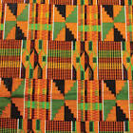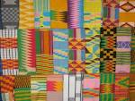

Carved Figures- typically made of wood
- Made out of one piece of wood and typically reflects the size and shape of the wood it was carved from
- Adze- an ax like tool that has an arched blade used for African Carvings

- 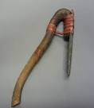

- Figurative Sculptures- Figurative means the sculpture looks like human figures or bodies
  - Little or no movement, the figure looks stiff or frozen in place
  - Large heads to represent the people’s importance they put on wisdom and inner peace
  - Symmetrical and frontal poses
  - Proportions of the body (size of each limb or part of the human body) reflects cultural beliefs rather than what people actually look like

  - 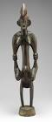
- Notice how the figure is a mirror image, the left side is the same as the right side
- Look at what features are exaggerated
- This is an example of a frontal pose because the sculpture is suppose to be viewed from the front

- Primordial Couples- represents the first man and woman

- 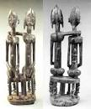
- All religions have their own version of the first man and woman or the creation theory
- Christians have Adam and Eve, Africans have numerous figures that depict their version of the first man and woman

- Olowe of Ise- Yoruba artist who did mainly wood carvings
  - @ 1875-1938
  - One of the only known artists of the time from Africa
  - 