Lesson #16
Guided Reading
Romanesque Art

The Romanesque Period- churches became larger and more Roman looking
- Vaulted ceilings
- Exterior decorated with relief sculptures
- Main purpose of Romanesque castle: defense and protection
- Churches became larger to support more members making pilgrimages

Feudalism- essentially people fighting over land
- Because land was the only source of wealth, the weak would trade land in order to gain protection from wealthier lords
- Land was seen as currency or money

Castles- Because the Medieval Period was a time of war and the land was not at peace because there was a huge gap between rich and poor, castles were built to secure and protect
- Developed around the idea of defense
- Thick walls
- No windows
- Minimally furnished on the inside
- Very plain
- Tapestries- embroidered textile wall hangings, usually seen in castles
  - Depicted battle scenes, however mostly religious scenes

Romanesque Churches- Characterized by looking like it came from the Rome
- Role of the Church: center of everyday life, so a lifestyle
- Used imagery to tell stories of the Catholic faith
  - Most people could not read or write. Because the church wanted to get more members and people proclaiming their faith, they used pictures to tell stories s more people could understand
  - Imagery was meant to scare people into the Catholic faith
    - Mentality: If you don’t convert or follow the faith, this is what will happen…
  - The entire society was in charge of building and planning of the churches.
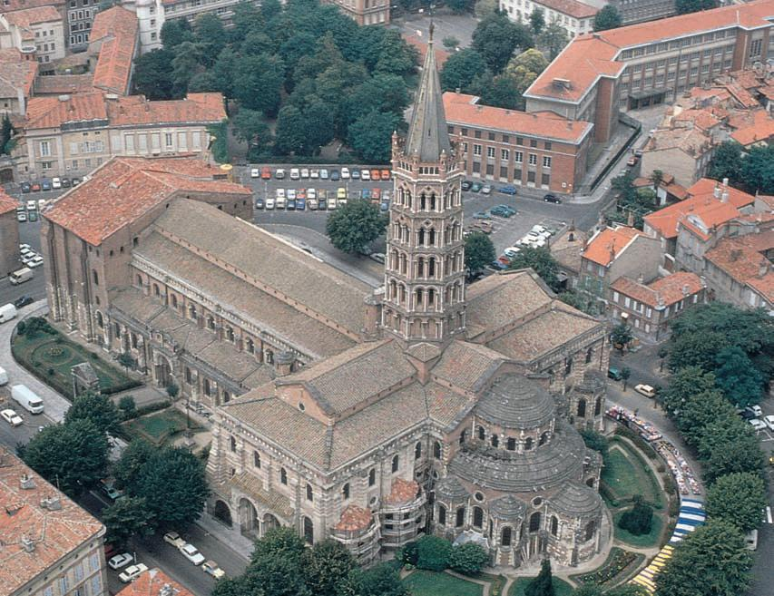
Notice how the shape of this church is in the shape of a cross?

“The Church of Saint Sernin” in Toulouse France

Why would the whole society have to work together to build or plan the building of a church?
_________________________________________________________________________________________________

_________________________________________________________________________________________________

_________________________________________________________________________________________________

_________________________________________________________________________________________________

- Tympanum- above the doorway between the lintel and the arch
  - Depicted low reliefs of a religious scene

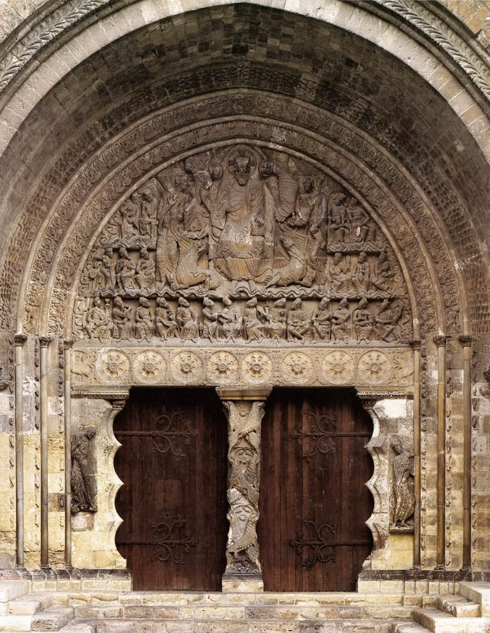
Notice the area that is above the door and the lintel (the horizontal area directly above the door) … It’s the tympanum

This is where we see most all of the relief sculptures on Romanesque Churches

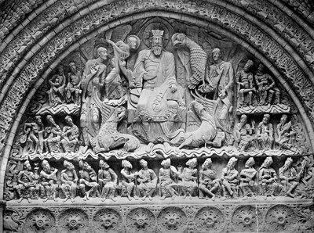
This is a zoomed in picture of the tympanum. This is where we start seeing some interesting imagery or subject matter on churches.

We can assume that the center figure is God, Jesus or the Pope. What is happening to the figures below him?
- Ambulatory- aisle in church that curves around and behind the main alter

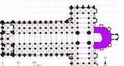
The highlighted purple color is the “Ambulatory”

This area is where the alter is located

This is also the front of the church

- Pilgrimage- journey people would make from the area @ 100 mile radius to proclaim their faith in the Catholic church and Christianity (Think about the Pilgrims that immigrated to the USA or colonies, they were on a religious mission too)
  - Reason Pilgrimages Started:
  - Relics- an object that has religious significance
    - Every religion has relics…
    - Christians-Jesus’s crown of thorns, Saints body parts, Mary’s Veil, the blood of Christ, etc.
    - Buddhism- Buddha’s ashes
    - Islam- The Holy Mantel- a piece of Muhammad’s clothing
  - Reliquary- a container that holds a relic, usually highly decorated and depicts stories on the outside

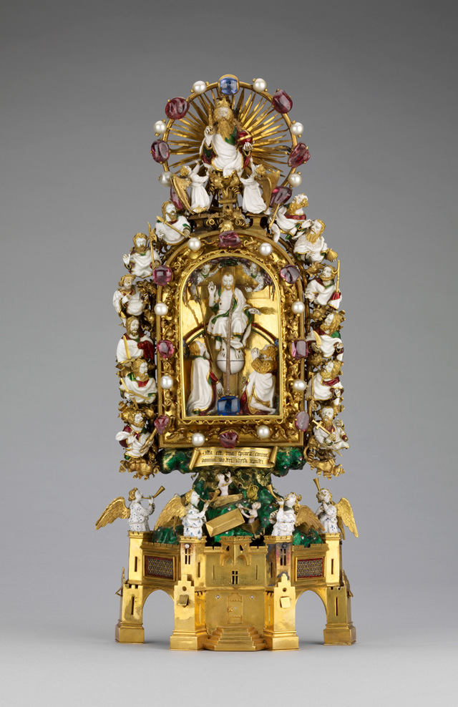
Holy Crown of Thorns

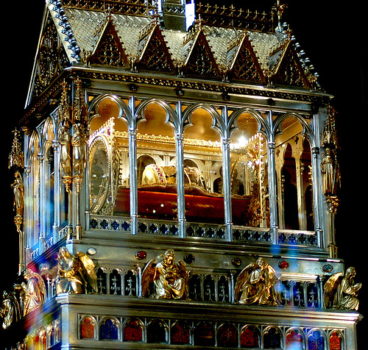
The Holy Right Hand of St. Stephen

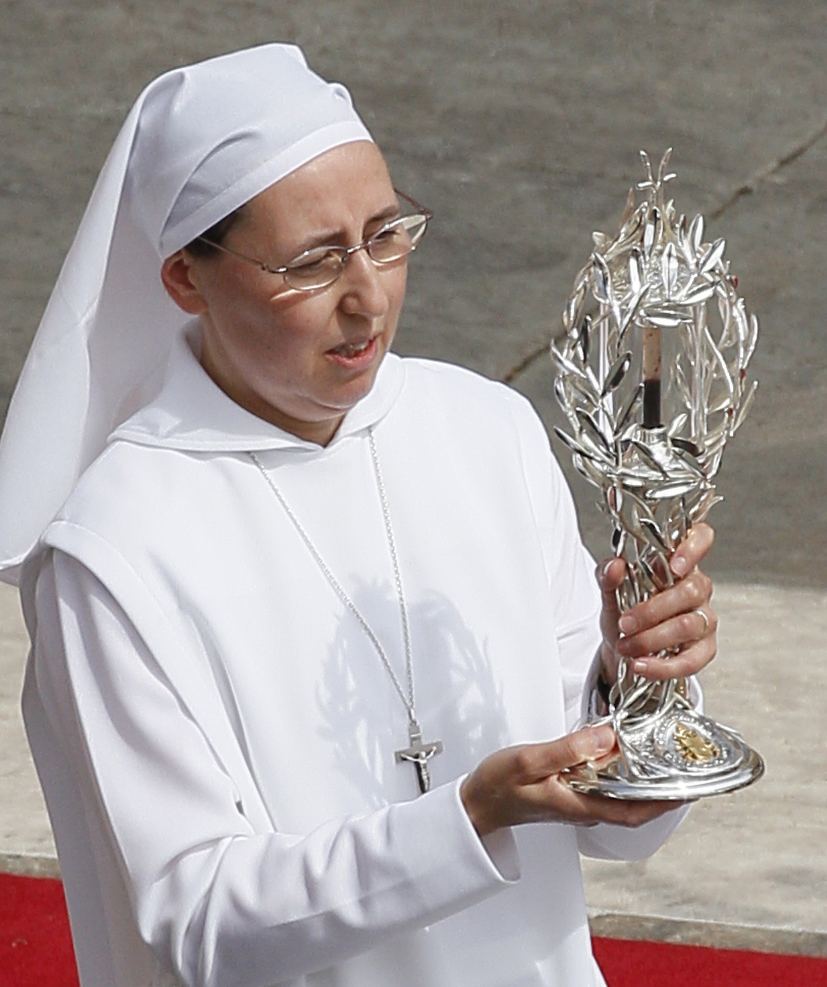
The Blood of Jesus Christ

