Lesson #20
Guided Reading
Renaissance Ideas

Paolo Uccello- @ 1397-1475
- Renaissance artist and painter
- Uses perspective I his artworks
- Created “The Battle of San Romano”
  - @ 1438-1440
  - Details a battle between Florence and Siena
  - Uses a grid pattern to define his perspective
  - Uses foreshortening as way of using perspective to draw figures so they appear to recede or protrude from the three-dimensional space

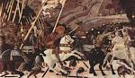

Piero della Francesca- @ 1420-1492
- Used ideas that were from Giotto and Masaccio
  - Solid, life-like figures
  - Paintings looked like Greek sculptures
  - Strong gestures in the way figures are positioned
  - Used strong sunlight or a light source to give a dramatic effect on figures and landscapes
  - Uses the concept of “contrapposto”
    - Refers to a pose in which the weight is shifted onto one leg to create an uneven balance to the figure
- Created “The Baptism of Christ” @ 1450’s
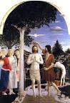
The Baptism of Christ

- Shape- branches on the trees, the arch of John’s arm direct our eye to Christ’s face
- Line- The mountains arch downward framing Christ’s face, right below his head.
- Color- makes the figures seem more realistic
- Light- brightness of the colors in the landscape seem to flow around the figures, making them appear more solid

Donatello- @ 1386-1466
- Greatest sculptor in Early Renaissance
- Influenced by Classical Roman sculpture
- Realistic feel and use of perspective
- Upper part of the bodies, the torso and head area, are elongated that way when we view them from the ground, they appear more realistic

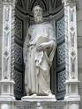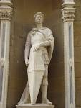

Filippo Brunelleschi- @1377-1446
- Credited for inventing linear perspective
- Traveled with other artist Donatello to Rome
  - Studied Roman architecture
- Proposed a dome design for the Cathedral
  - Design was accepted and building process lasted for sixteen (16) years
  - Michelangelo studied his work on the dome and used his design concept in creating the dome for the Church of St. Peter’s in Rome
- Duomo- refers to a cathedral church in Italian

The Pazzi Chapel- created by Brunelleschi @ 1430
- Commissioned by the Medici Family- the most wealthy family during the Renaissance
- Created a balance between horizontal and vertical aspects of the construction
- Harmonious style of ancient Roman influence

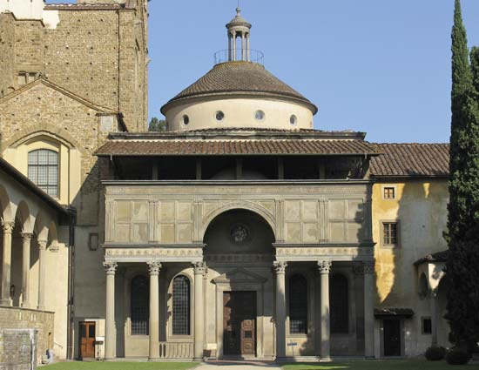
Exterior Picture of the Pazzi Chapel

Did you expect the Chapel to look more elaborate?

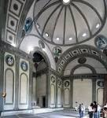
Image of the Interior of the Pazzi Chapel

Notice the dome area and how light is let in by the holes or windows in the “duomo”

Can you see the detail in the horizontal (-) and vertical (I) lines seen on the walls?

Sandro Botticelli- @ 1445-1510
- Renaissance painter who used the design elements and principles to achieve a well designed work of art
- Created “The Adoration of the Magi” @ 1481
  - Line- draws the contours, or outer shape of figure
  - Proportion- stretched the upper body of Mary in the painting to give her an even/ more elegant look
  - Emphasis- used to unify and point out the most important parts of the painting.
    - The central figures create a triangle shape around them with Madonna or Mary at the top
    - If the line is extended from the triangle to enclose to include all figures, a “W” shape s formed

