Lesson #21
Guided Reading
The High Renaissance

Leonardo da Vinci- @1452-1519
- Although he was known as a Renaissance painter and sculptor, he also studied the following subjects…
  - Mathematics
  - Architecture
  - Painting
  - Sculpture
  - Music
  - Geology
  - Botany
  - Hydraulics
- Left-handed and devised a way of recording information in his journals in his own writing system.
  - Wrote from right to left and his letters were backwards
  - If you held a page up to your chest with the words facing out and a mirror in front of the page, you could read it perfectly
- “The Last Supper”- @ 1494-1498
  - Tried a new way of painting a fresco (pigment on wet plaster)
  - Did not work and began to flake off shortly after it was finished
    - The last supper we see today is not original to Da Vinci, it has been redone/re-mastered multiple times

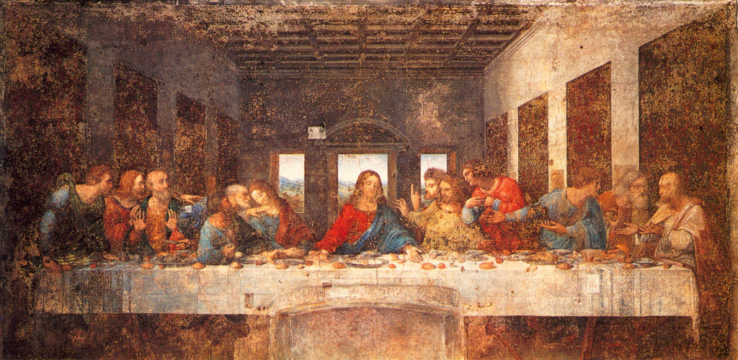
This image is a clearer version that has been refurbished.

Do you see the figures are depicted in groups of three (3) except one figure?

Judas, the person that betrayed Jesus, is the third person on the right who is separated
In this image of “The Last Supper” we can see what happened shortly after Da Vinci painted this scene. Can you tell where the painting started to crack and deteriorate?

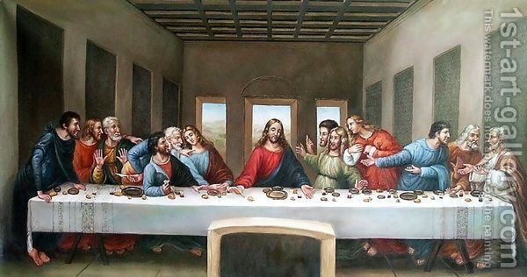
- The Mona Lisa- @ 1503-1505
- Worked on this painting for 16 years
- Never felt finished
- Never satisfied with his work
- One of the most popular artworks of all time

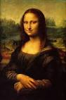
Fun Facts about the Mona Lisa

- Da Vinci painted figures starting with the bone, adding muscles, tendons, skin, hair and finally clothes.
- It took 16 years to create
- The actual size on the Mona Lisa is a lot smaller than you think…
- Some historians believe that Mona Lisa is a self portrait of da Vinci as a female.

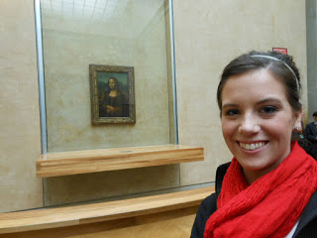
Look how small it is!

The Mona Lisa is only 30 inches by 21 inches. Small right?

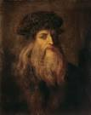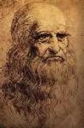
Check out the self-portraits of da Vinci!

Around this era, we start seeing images or paintings of artists
Michelangelo Buonarroti- @1475-1564
- Sculptor, painter and poet
- Preferred sculpture, specifically in marble and 3D figures
- Imitated Classical Greek and Roman sculpture

Pieta- @1499
- Located in the St. Peter’s Basilica in Rome
- Pieta= pity in Latin
- Image of Mary holding Jesus after crucifixion
- Michelangelo was in his 20’s when he began sculpting this work of art
- Focuses on religious meaning rather than realism
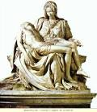
Madonna= The Virgin Mary

Mary’s body is a lot larger than Jesus so she can appear to support her son

Realism is not the point of this sculpture.

It’s more about placing focus on the emotions and religious meaning.

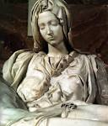
Does the Madonna look at peace or mournful after her son’s death?

If you could describe this emotion, what would it be?

Why do you think Michelangelo depicted Mary this way?

The Sistine Chapel- @ 1508-12
- Located in The Vatican
- Pope Julius II MADE Michelangelo paint the Sistine Chapel ceiling
- Pope Julius II commissioned Michelangelo to paint the ceiling of the Sistine Chapel
- Michelangelo HAS to accept the job or else it would have been considered treason or going against the Catholic Church. Remember: the Catholic Church at this time was corrupt and had more power than the state or government at the time.
- Does not want to paint the ceiling for these reasons…
  - Other artists had already painted the walls of the Chapel
  - The ceiling was not typically a popular place to paint because of the difficulty and you cannot view it closely.
  - Did not agree with the Pope or the Catholic Church, therefore he did not want to contribute to the Church.
2. Michelangelo tells his workers to prepare the ceiling for a fresco
- The workers have to put plaster on the ceiling and is a time consuming and difficult process
3. Michelangelo “changes his mind” to paint the ceiling in tempera
- Workers then have to scrape all the plaster off the ceiling and smooth the surface
- Michelangelo was stalling because he did not want to paint the ceiling AND it was his way of telling the church and Pope Julius no without actually saying “no” or going against the Catholic Church.
4. Michelangelo changes his mind AGAIN and wants to paint in fresco
- Workers have to prep the ceiling for fresco, applying plaster to the ceiling
- Pope Julius II tells Michelangelo that he HAS to paint the ceiling, otherwise it will be considered an act of treason against the Catholic Church
- This means Michelangelo would have been annexed or shunned from society, never being able to make a living creating art.
5. Michelangelo paints the Sistine Chapel in fresco
- Painted the Chapel in 4 years
- Used scaffolding, a pulley system and was extremely dangerous
- Michelangelo was hanging horizontally or laying on a wooden plank about 2 feet from the ceiling in order to paint
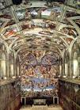
Notice how high the ceiling were…

Do you think Michelangelo was afraid of heights?

Can you imagine what it would be like to be dangling from a ceiling in the early 1500’s?

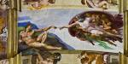
This is one of the most popular images depicted in the Sistine Chapel

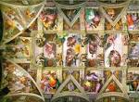
Each area is a different image of “Heaven” or Biblical scenes

Can you imagine how hard it would have been to paint a ceiling with such precision, detail and area in only 4 years?

Michelangelo’s Character/Personality-
- Moody
- Loner, didn’t like to socialize or function in society
- Temperamental
- Hard to work with

Raphael- @ 1483-1520
- Was inspired by both Da Vinci and Michelangelo
  - Da Vinci- learned to perfect perspective
  - Michelangelo- learned how to give his figures energy and placement of figures in dramatic groups/poses
- Characteristics/Personality-
  - Outgoing
  - Was successful early in his life
- The School of Athens- @ 1520-1511
  - “Greatest masterpiece”
  - Title meaning: Athenian school of thought
  - Depicts Aristotle and Plato in the center, walking through the school
  - Located in the Vatican

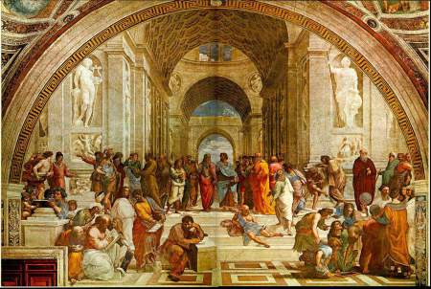

- Can you see the use of linear perspective?
  - The arches and walls of the school recede into the background
  - The figures in the foreground are larger than the figures in the background

Women Artist’s of the Renaissance-
- Not typical of the time period
  - Women were expected to stay home
  - Raise the family or children
  - Help on the farms
- Artists usually had to go to school
- Receive special training
- Travel

Sofonisba Anguissola- @ 1532-1625
- First famous female artist
- From Cremona Italy
- Worked for the Court of King Phillip II of Spain
  - Commissioned to paint portrait of the royal family
- Called her a “Lady in waiting” so it didn’t seem she was working
  - Ended up marrying a noblemen from Sicily
- Most famous Artist of the Late Renaissance period

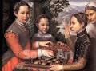
Sisters Playing Chess
@ 1555

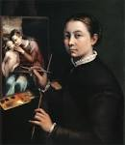
Self-Portrait
Sofonisba Anguissola

