Lesson #26
Guided Reading
Baroque Art of Italy and Flanders

Baroque- style of art from 1600- 1750
- The Catholic Church was refortifying itself, or trying to make itself better
- Hoped change would bring people back and fight the heresy
- This is known as the Counter Reformation- trying to win Protestants back to the Catholic Church
- Papacy- the office of the pope
  - Commissioned artists to create artworks on a grand scale in hopes of making Rome the most beautiful city in the Christian world
- Popular artists of the Baroque Period include..
  - Rubens
  - Van Dyck
  - Caravaggio

Michelangelo da Caravaggio- @1571-1610
- Northern Italian painter of the Baroque period
- Most well known for chiaroscuro
  - Chiaroscuro- dramatic arrangements that focus on use of light and dark areas
    - Chirao- derives from the Italian word bright
    - Scuro- derives from the Italian word dark
- His revolutionary style changed European paintings during the 17th century by his unique use of light in artworks
  - Heavily influenced Rubens and Rembrandt

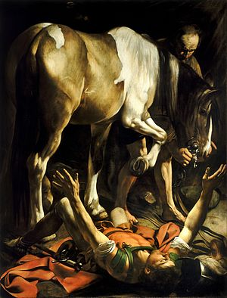
The Conversion of St. Peter
- @ 1601
- Depicts a scene from the life of St. Peter who was converted when he fell off his horse on the way to Damascus
- Notice how the use of light and dark areas make the painting seem dramatic
- Look at the figures in action
- See how the colors are intense

***Please see the Text that begins with the following heading***
Analysis of the Painting with Art Criticism Operations

1. Description- describe the images you are seeing in terms of the design elements
- Color, type of painting (Emotional, Formal or Imitational), subject matter etc.

2. Analysis- describe the design principles you see
- Give a description and analysis of the principles you see and why/how you see them

3. Interpretation- What do you think the painting is about?
- Describe what you think the meaning behind the work of art is.

4. Judgment- Do you like the work of art?
- Why/why don’t you like the artwork
- Use specific examples to defend your opinion.

Artemisia Gentileschi- @ 1593-1653
- Female artist of the Baroque Period
- Used chiaroscuro to create dramatic scenes
- Painted religious and historical paintings

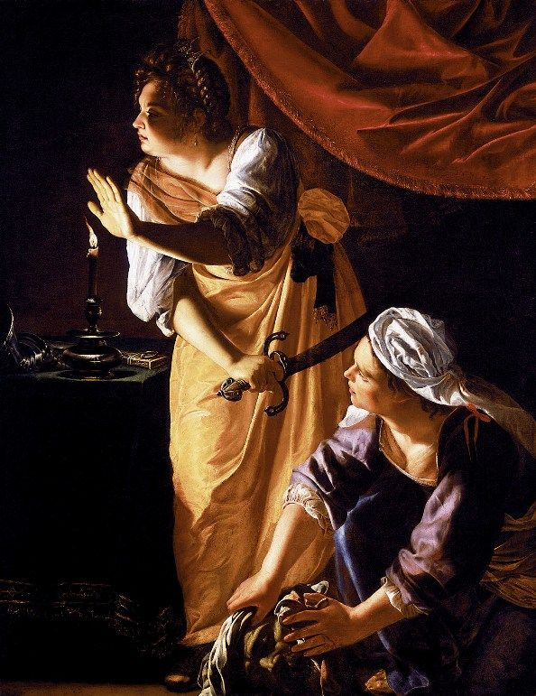
Judith and Maidservent with the Head of Holofernes
- @ 1625
- Biblical story of famous heroine
- Judith kills Holofernes who is the enemy of the Jewish people by cutting off his head when he slept
- Use of story-telling
- Use of chiaroscuro

Peter Paul Rubens- @ 1577-1640
- Flemish painter
- Brought Baroque style to Northern Europe

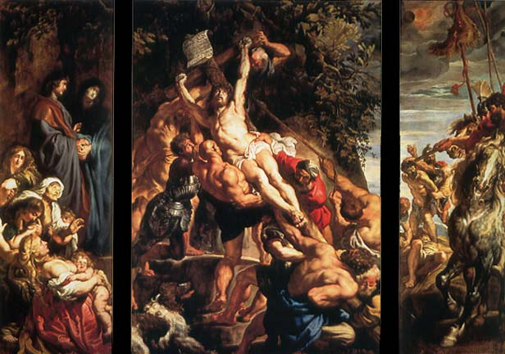
The Raising of the Cross
- @1609-1610
- Use of Caravaggio in lighting, not quite as dramatic as chiaroscuro
- Figures are extremely muscular
- Uses pyramid shape when positioning figures

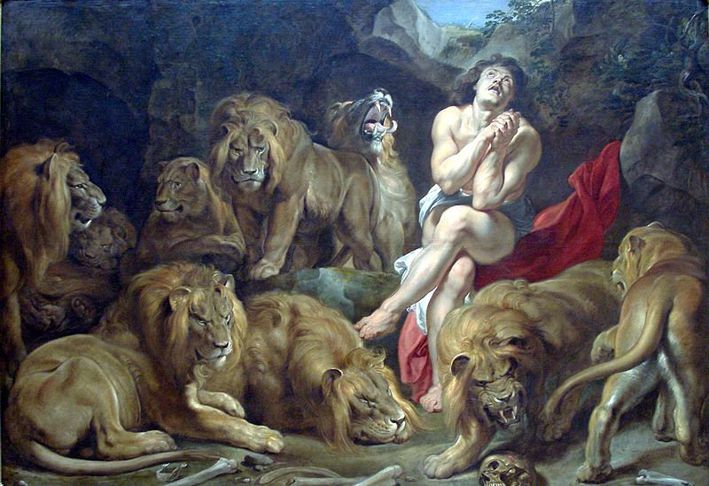
Daniel in the Lion’s Den
- @ 1615
- Story of the Biblical prophet Daniel, in intense prayer that he does not get eaten; seems to be working because the lions are not paying attention to him
- Obvious use of chiaroscuro because of the light coming from the opening in the ceiling
Anthony van Dyck- @ 1599-1641
- Flemish Baroque Painter
- Assistant to Rubens in his twenties (20’s)
- Became Court Painter to King Charles I from 1632-1641

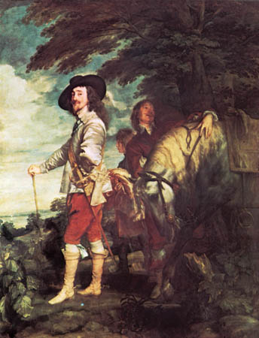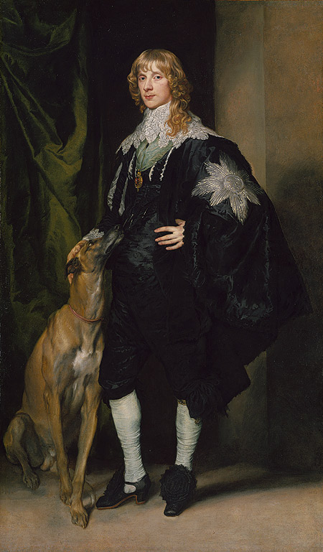
Portrait of Charles I Hunting
- @ 1635
- Less formal than usual portraits of royalty, however still has a sense of elegance and grandness
Duke of Richmond and Lennox
- @ 1637-1639

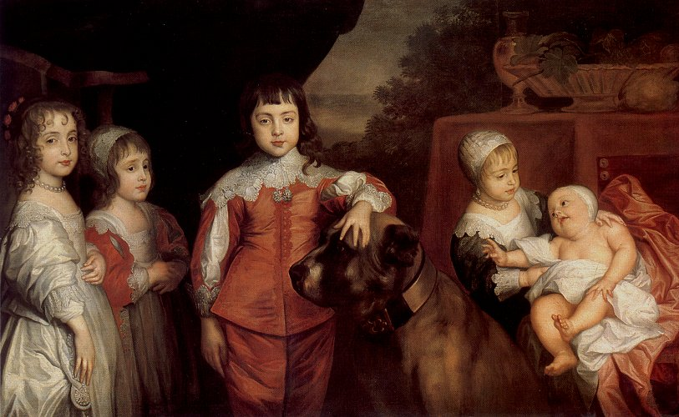
Charles I’s Children
- @ 1639
- What is different about these portraits is the Royal Family are depicted in real life situations
- More naturalistic
Church Architecture-
- Il Gesu- one of the first to incorporate new features into the design
  - Façade- the front of the building
  - Important aspect of the Baroque Style in architecture
- Francesco Borromini- architect of the Church of San Carlo alle Quattro Fontane
- Gianlorenzo Bernini- @ 1598-1680
  - Sculptor turned architect
  - Designed colonnades
    - Colonnades- A series of columns placed at regular intervals
  - Created a bronze canopy over the high altar at the piazza of St. Peters

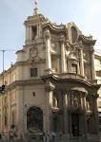
San Carlo alle Quattro Fontane
- @ 1665-1676
- Classical Baroque Architecture Style

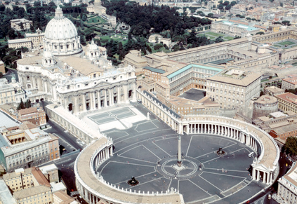
Basilica of St. Peter
- @ 1506-1626
- The round area is made from colonnades
- See the use of columns to made a type of breeze way

