Lesson #27
Guided Reading
Dutch Art

Baroque Style in Dutch Art- not as present as it was in Catholic countries
- The Treaty of Westphalia- divided the low countries into two (2) parts
  - South- Flanders area remained Catholic and was a territory of Spain
  - North- Holland area (was mostly Protestant)
    - The Baroque Style had less of an impact because it was geared more toward Catholics.
    - Because Holland area was mostly Protestant, the Baroque style had little to no impact.
    - Protestant’s also did not want religious artwork in their churches.

Frans Hals- @ 1582-1666
- Combined Ruben’s and Caravaggio’s style in order to create his own personal artistic style
- Mostly painted scenes of common people and daily life

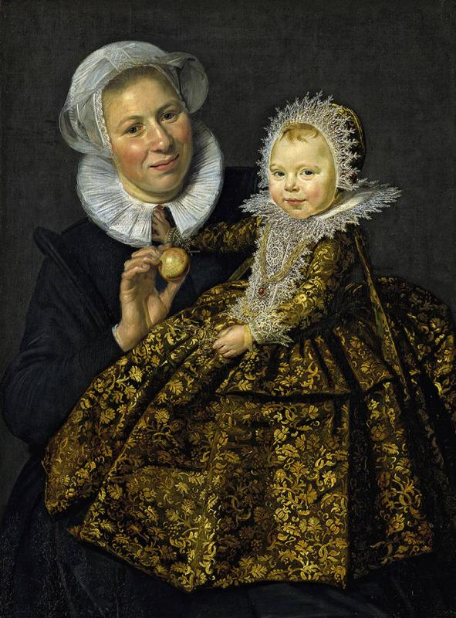
Portrait of Catherine Hooft and her Nurse
- Do you think it’s weird the painting is named after the baby than the older nurse?
- Used quick brushstrokes
- Captured a fleeting moment and recorded it
- Notice that the paintings during this time were “in the moment”

Rembrandt van Rijn- @1606-1669
- Considered one of the best Dutch painters of this time period
- Didn’t focus on just on genre of painting
  - Painted in ALL genres
  - Genre- scenes from everyday life
- Placed certain areas of the painting in a shadow to increase viewers curiosity

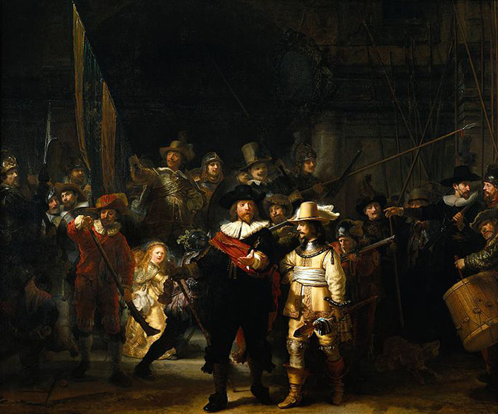
The Night Watch
- Portrays a military company who funded their own war
- Use of dark shadows
- Painted on a large canvas

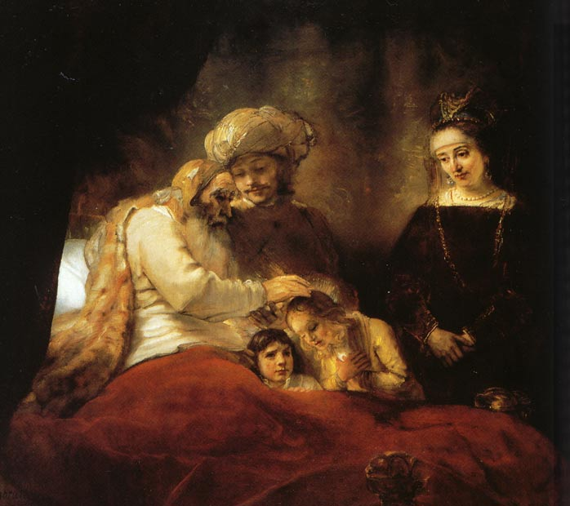
Jacob Blessing the Sons of Joseph
- Created @ 1656
- Notice the difference between the first painting and this one
- Why do you think Rembrandt made this painting ore hazy?

Jan Vermeer- @ 1632-1675
- Known for painting interiors
  - Paintings look like the viewer is looking in on a scene
- Only painted less than 40 paintings in his lifetime
- Finds serene spiritual beauty in the everyday scenes around him

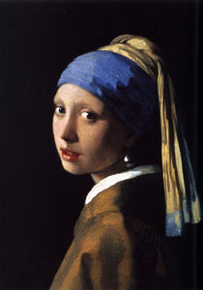
Girl with a Pearl Earring
- Created by Vermeer
- Originally called Girl with a Turban
- Title changed in the second half of the 20th century
- Believed to be Vermeer’s eldest daughter
- The “Mona Lisa” of Dutch Art

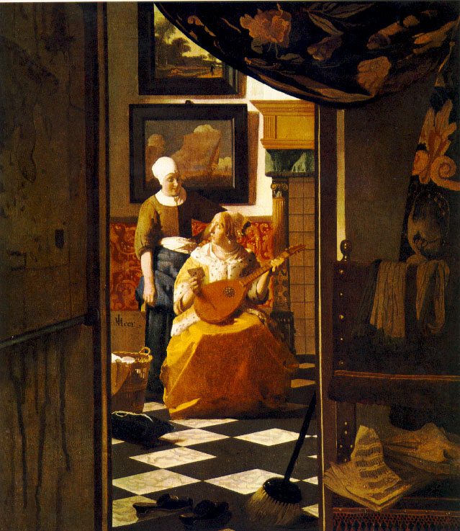
The Love Letter
- Looks as if you’re looking into a scene that you’re not suppose to see
- Notice all the details of each object
- Who do you think these ladies are?

Jan Steen- @ 1626-1679
- Painted mostly narrative scenes
  - Paintings that told a story
- Ran an inn to supplement his income as an artist

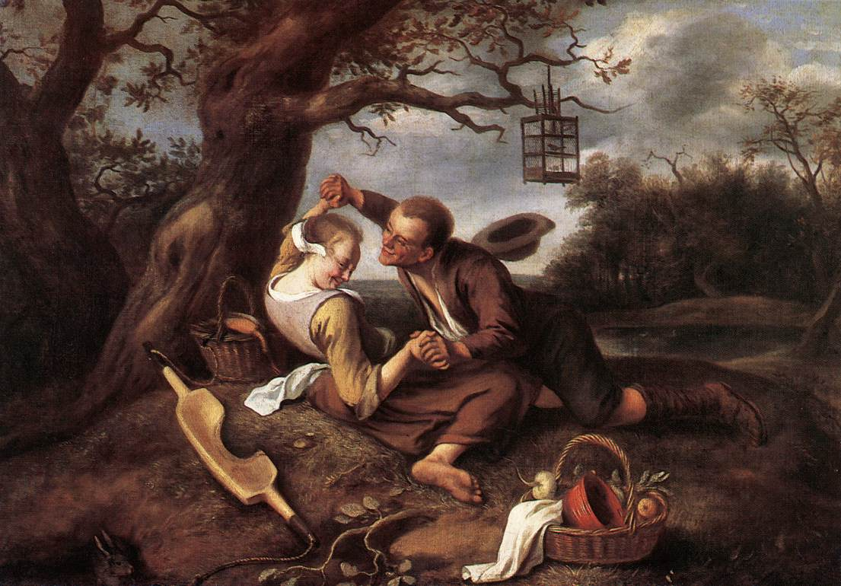
Courting Couple
- One of the earlier works by Steen
- Also known as the “Merry Couple”
- Can you tell this is like a scene from a story?

Judith Leyster- @ 1609-1660
- Female Dutch artist
- Painted mostly portraits
- A member of the Guild of St. Luke
  - An art school in Haarlem where she may have worked with Hals
  - There were only two (2) female artists that were members there, one included herself
  - Haarlem- town in Holland where the Guild of St. Luke was held.

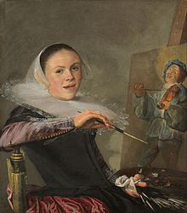
Self-Portrait
- Leyster is able to capture a natural pose
- Do you think the artist was able to catch herself in the most natural state of being?

