Lesson #29
Guided Reading
Rococo Art

Rococo Art- an art form which placed emphasis on the life of the aristocracy in the 18th century
- Aristocracy- nobility, wealthy upper class commonly known as aristocrats and the rulers of the absolute monarchy
- Absolute Monarchy- government of Kings and Queens, however the King holds absolute power, meaning he makes all of the decisions or has the final ruling.
- Characteristics of Rococo Art-
- Pastel colors
- Images of wealthy people
- Usually see people at leisure
- Scenes of Romance and Love
- Images of wealthy people at their “Chateaus”
  - Chateaus- a manor or country home of the nobles in France; very much like a vacation home outside the city
- Fete galante painting- paintings that depict an outdoor scene of people having a party (outdoor parties)

Baroque v. Rococo Art
- Baroque=
  - Drama
  - Light v. dark
  - Movement
- Rococo=
  - Playful
  - Whimsical use of line and color
  - Pastel colors and looks soft

Antoine Watteau- @ 1684-1721
- Considered the greatest painter during the Rococo Art Period
- Court painter for King Louis XV (15th)
- At first, his artwork wasn’t popular, however it later spread to all of Europe
  - Only became popular near the end of his life

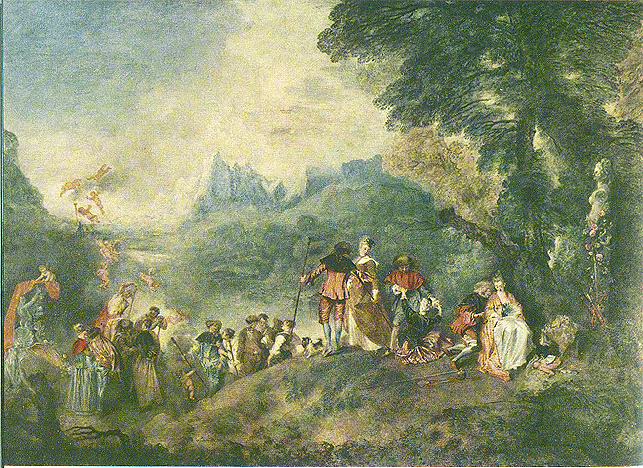
Embarkation for Cythera
By: Watteau
Created: 1717-1719
Story: Aristocrats are leaving a mythical land of romance and love that is believed to be the birthplace of Venus the goddess of love.

Jean-Honore Fragonard- @1732-1806
- Was a court painter before the French Revolution
- After the Revolution, he escaped to South France to continue to paint
- Because he was creating artwork during a time of war, his artwork was never popular or wasn’t able to work for the courts
- He only became famous after his death
- Greatly influenced the Impressionist painters

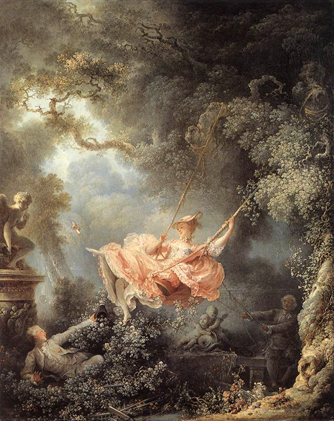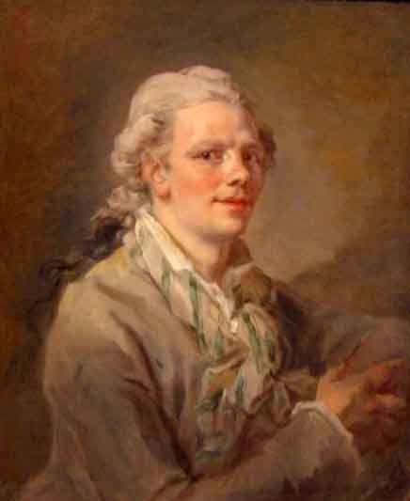
“The Swing” Self-Portrait of Fragonard
- Unified the artwork through axis and contour lines
- Example: the clouds, ropes on the swing, the man’s arm are all drawing your eye back to the center of the painting.
Jean-Baptiste Simeon Chardin- @ 1699-1779
- Even though Chardin lived during the time of the Rococo Art Period, he went against the painting style and subject matter
  - Painted commoners or maids/servants
  - Painted a scene of everyday life or common situations
  - Also painted still-life

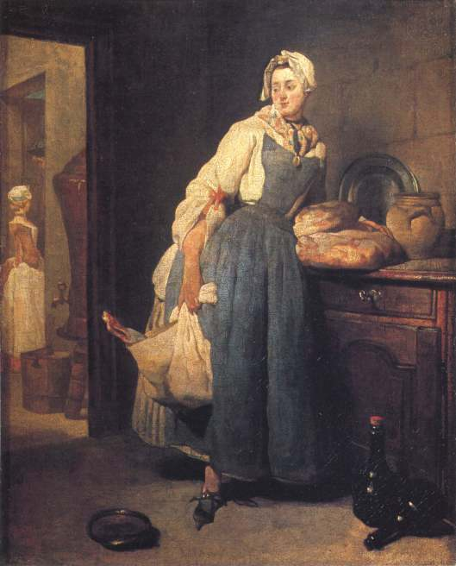
Back from the Market
By: Chardin
Created: 1739
Story: The scene depicts an image of a middleclass lady who has just arrived back home from the market.
Reasoning: Chardin didn’t want to paint the life of the aristocracy because he found beauty in the middle class peoples as well as everyday life and activities people performed.

