Lesson #34
Guided Reading
Art of the Early 20th Century

The Fauves- “wild beasts” or “savages”
- Had little regard for portraying nature realistically
- Were inspired by the Post-Impressionists, however made their artwork more flat and colorful
- Purpose of art is to comfort and give pleasure

Henri Matisse- @ 1869-1954
- Leader of the Fauves
- Interested in decorative design that came from studying Asian carpets and African imagery
  - Ex. Merging a design on a table cloth with the wallpaper
- Goal was to make artwork simple in order to be more direct

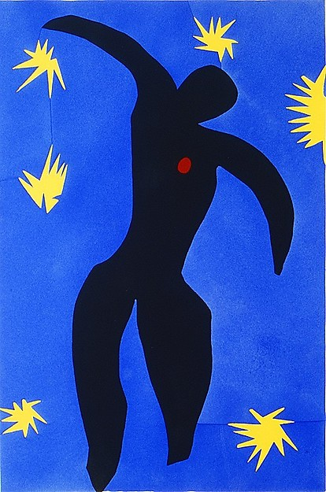
Icarus- @ 1947
- Uses positive and negative shapes to create a simplified image
  - Positive Space- Includes the black figure
  - Negative Space- Includes the blue background, stars and heart
- Looks childlike in nature and seems very flat or stiff

German Expressionism- communicated their deepest personal feelings through their artwork
- Expressionism- expressing yourself through artwork or artwork that expresses strong emotional feelings
- Exaggerated color, facial emotions, etc.

Edvard Munch- @ 1863-1944
- Early life- a lot of tragic events happened to him
  - Death and illness in his family
  - 1877- Sister Sophie died of tuberculosis
  - Created a painting entitled “The Sick Child”, painted in 1907
- Best known for “The Scream”

Cubism- art in which the artist tries to convey all sides of an object on a flat surface at one time
- Directly linked/inspired by the artworks of Paul Cezanne
  - All objects in nature are based on simple shapes such as the cone, sphere and cylinder
- Cubist Collage- uses a variety of materials glued to paper or a canvas used by Picasso and Braque to create still-life works of art
- Collage- French word for “paste up”

Pablo Picasso- @ 1881-1973
- Born in Spain

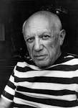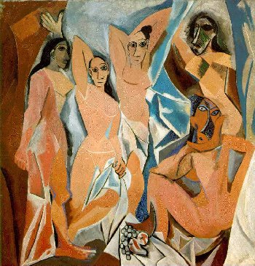
Les demoiselles d’Avignon

Picture of Picasso

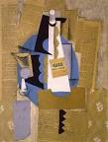
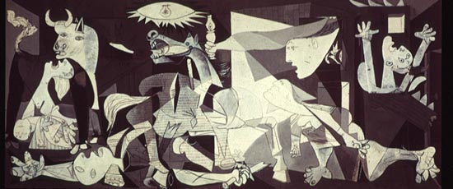

Guernica- By Picasso in 1937
- Famous anti-war mural
- Based on the Spanish Civil War
  - Made in reaction to the German terror bombings on the city of Guernica
  - Spanish Nationalists (One side of the Spaniards that were fighting each other) gave the go ahead to bomb the city
  - The bombing was merely to test a large scale bomb’s destruction ability
  - Picasso started painting this artwork “Guernica” 15 days after the attack

