Lesson #35
Guided Reading
Art from Mexico and the United States

The Mexican Mural Renaissance-
- Political and Social issues were abundant (happened a lot) in Mexico and prompted artists to create powerful works of art in response.
- Mexican Revolution of 1911-21- this movement brought about the fall or decline of the dictator Porfirio Diaz
  - Poor landless citizens of Mexico wanted to free themselves from the corruption of wealthy landowners
  - This time period was the source of inspiration for Mexican Muralists and artists alike.
- Mexican Muralists- included Diego Rivera, Jose Orozco and David Siqueiros
  - Depicted the plight of Mexican peasants, hero’s and enemies of the Mexican Revolution
  - Reacted strongly to suffering and war

Diego Rivera- @ 1886-1957
- Used the endless struggle of the Mexican peasants as his subject matter

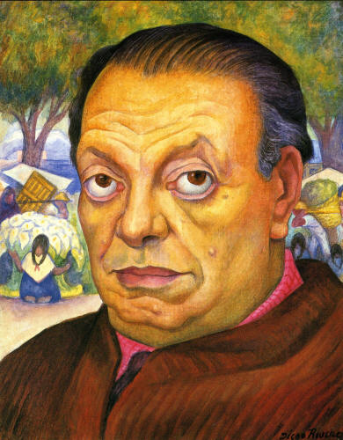
Self-Portrait of Diego Rivera
Fun Facts-
- Married to Frida Kahlo
- Rebelled against the traditional school of art and created his own style
- Traveled the US painting murals with Frida Kahlo
- Originally from Mexico

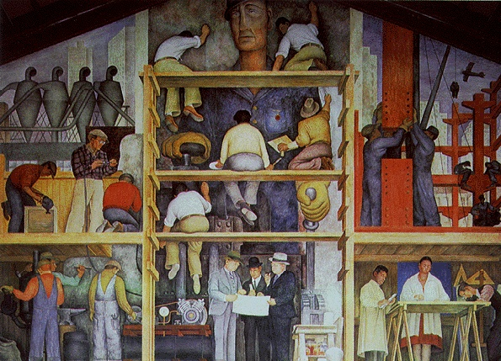
Created By:
Diego Rivera

Subject Matter: Artists painting a mural

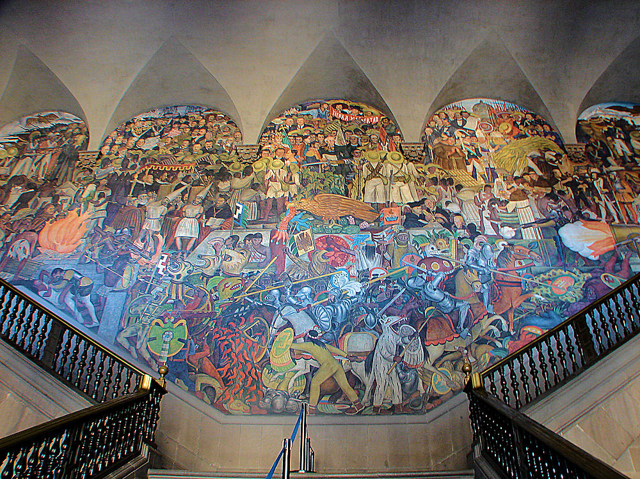
Check this out!

This mural is interesting because of all the extreme detail and how many figures Rivera used.

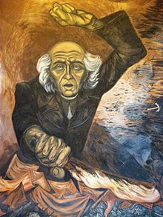
Jose Clemente Orozco- @ 1883-1949
- Mexican Muralist and friend of Diego Rivera
- Interested in showing the mechanization and dehumanization of modern life, rather than creating images that glorify the Mexican Revolution

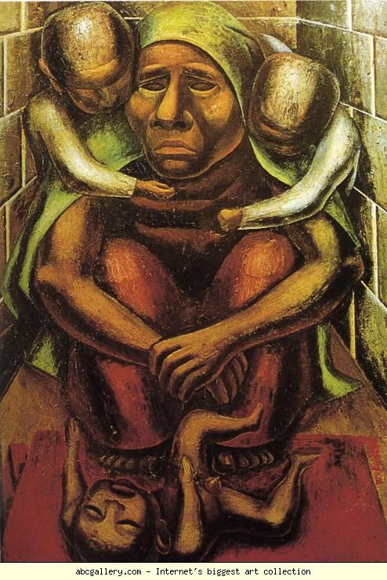
David Alfaro Siqueiros- @ 1896-1974
- The third (3rd) of the big three (3) Mexican Muralists
- Subject matter depicted the human struggle against oppression, particularly the working classes

Impact of the Mexican Muralist’s-
- All were influenced by the Mexican Revolution and used human suffering of the middle and lower classes as their subject matter.
- WPA (Works Progress Administration)- largest New Deal agency during the great depression of the 1930’s
  - Artists were paid to paint murals on city buildings both inside and out.
  - This was created in order to put more money into society and help the economy during the Great Depression

Frida Kahlo- @ 1907-1954
- Subject Matter: mostly self-portraits
  - Very sickly person
  - Worked mainly in bed because she was overcome with extreme pain
  - Sometimes she looked beautiful and other times she showed extreme pain and agony
- Interested in politics and the culture of the Mexican people
- Married Diego Rivera in 1929
- Some consider her work as Surrealistic

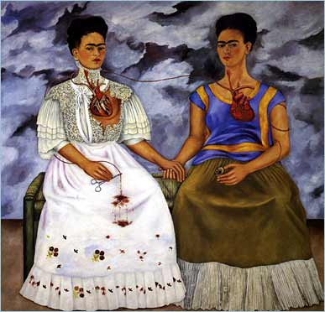

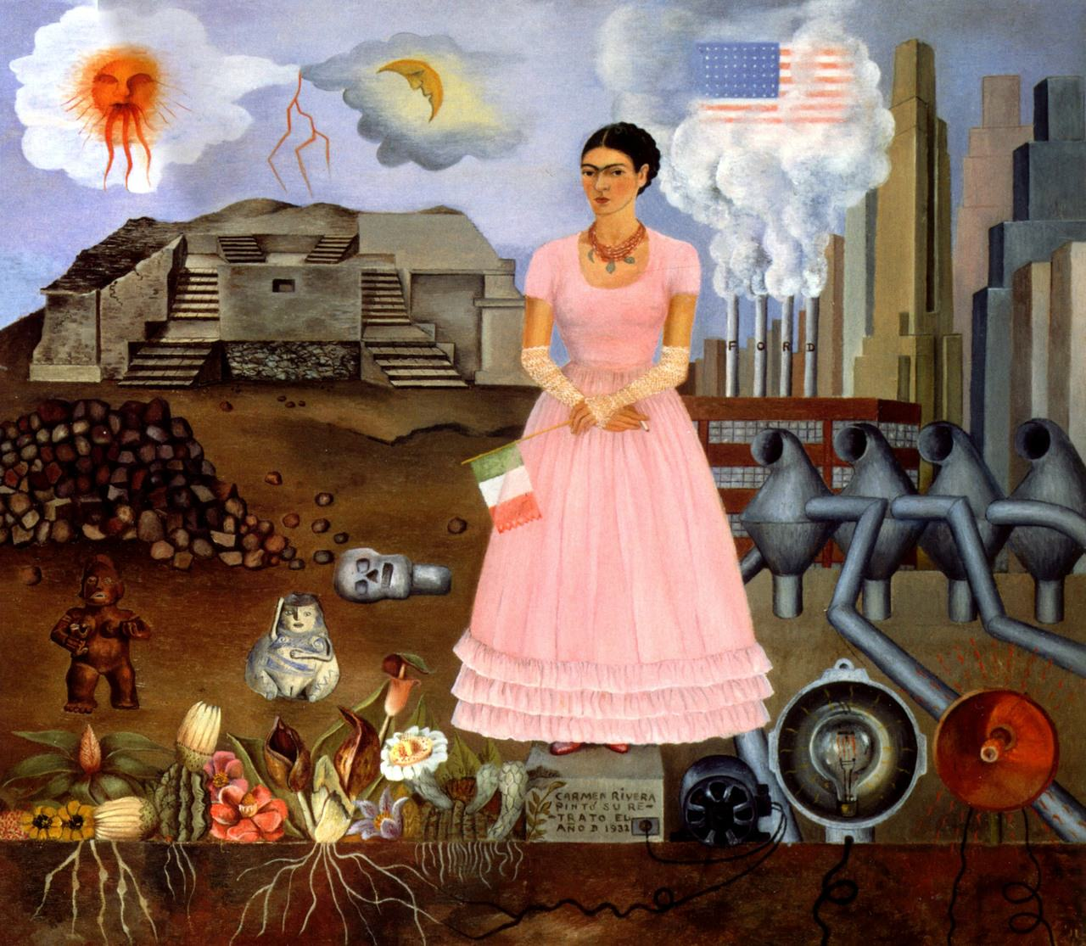

American Art-
- Big social and economic changes in America during this time
  - Model T Ford, Flappers (Ladies wore their hair “bobbed” and short slinky dresses), assembly lines, telephones, skyscrapers, locomotives and airships

Ashcan School- first showing of artwork was in 1908
- Artists wanted to record the excitement of the city, nightlife, alleyways, and theatres
- Wanted to capture life as they saw it around them, not in an idealistic academic manner
- Name of school was coined because people thought their artwork was as worthy as an ashcan (meaning not worthy at all)
- Painters included: Edward Hopper and George Bellows

The Armory Show of 1913-
- In New York City
- First exhibition of modern art in America
- Displayed over 1,250 works of art
- Created by both American and European Artists
- Important because it had a profound impact on artists of America
  - Influenced the “Modern Art” art movement

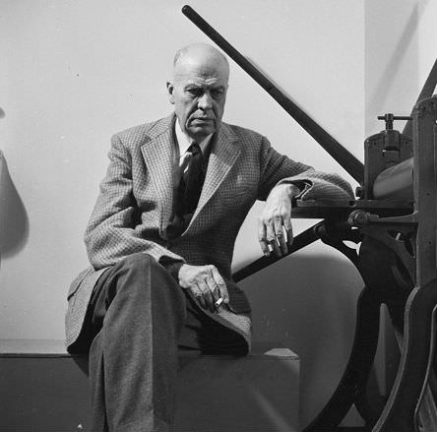
Edward Hopper- @ 1882-1967
- Influenced by the Realistic painters
- Didn’t like cubism, which was a big art movement during his younger years as an artist
- Best known for his later works

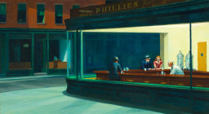
Nighthawks
Created By: Edward Hopper
Date: 1942
- The most famous and influential image by Hopper

George Bellows- @ 1882-1925
- Created paintings similar in style to those of the Ashcan School
- Subject matter included sports themes
  - Lived in New York City most of his life across the street from a boxing gym, which he painted most frequently

