Lesson #13
Guided Reading
Early Christian and Byzantine Art

The Fall of the Roman Empire-
- Divided the country into two (2) empires
- Were invaded repeatedly when the country was in shambles
- Ended in the 5th century

Early Christian Art-
- 313 ACE- Emperor Constantine signed the Edict of Milan
  - Edict of Milan- legal document which legally changed the official religion to Christianity and made Christianity legal to practice
  - Catacombs- underground passageways that were created so Christians could practice their religion, bury their dead and hide from the Romans. Also contained paintings and images that depicted or told a story of their religion.
  - Iconography- a system of symbols that use symbolism to tell a story through imagery or pictures.
  - Symbolism- an image that has a specific meaning
    - Examples:
    - Green Ivory- eternal life
    - Dog- loyalty
    - Lamb- God
    - Rivers- the four (4) Evangelists: Matthew, Mark, Luke and John
    - 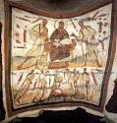

- Basilica- a style of building that the Romans used to transact business
- Nave- central section of the church and leads to the high altar
- Apse- a semi-circular area at the end of the nave, we usually see mosaics in this area
- Campanile- a bell tower
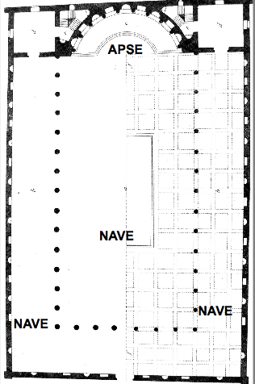
Here is a diagram of a typical Byzantine Basilica…
- Notice where the apse is located, in the front of the church where we see the alter and mosaics
- Look at the nave area, this is the walkway up to the apse or alter. Think of the nave as the walkways in a Basilica
- Mosaics- a style of decoration made out of small pieces of glass, stone or glazed ceramic tiles that are set in cement
  - Creates an image or scene
  - Looked glossy or had a glittery sheen
Key Characteristics of Byzantine Mosaics-
- Outlined in black tiles
- Jesus always has a halo around his head
- Jesus usually has his hands in the “peace sign” position
- Clothing has lots of folds in the fabric
- Elongated nose
- Usually in frontal position
- Figures or people look flat or stiff, almost like they are frozen in place
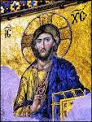

- House of Mystery- slang term for the churches during the early Christian era
  - Because the churches were filled with candles, light flickering from the windows, the mosaic tiles seemed to glow and glitter, producing a mysterious effect

Byzantine Art and Culture- the Eastern half of Constantinople
- When the Roman Empire was at a decline, Byzantine started to flourish
- Artists were influenced by Greek, Roman and Eastern cultures
- Artists were commissioned by the Catholic Church and the Pope
  - All art was religion based during this time period

Power Grows in the Catholic Church-
- Because Christianity became the new religion, the Pope and the Catholic Church’s power grew.
- People were devout or dedicated to their religion and would do anything to get into heaven
- There was no separation between church and state
  - In the US, we have separation between the church and our government

Byzantine Architecture and Mosaics-
- The Hagia Sophia- means “The Church of the Holy Wisdom of God”
  - Built in the 6th century in Constantinople
  - Huge dome the rests on piers or large pillars
  - Architects were able to create more windows and thinner walls
  - Dim light reflecting off the walls, where mosaics were positioned, allowed people to see the religious images from a great distance
  - Used symbols/symbolism to tell religious stories on the mosaics
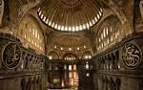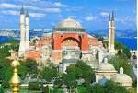

Ravenna- Western half of the Byzantine Empire
- Became the capitol of the Roman Empire in the 5th Century ACE
- Emperor Justinian- became the ruler of Ravenna in 540 ACE
  - Recaptured Ravenna from the Barbarians
  - Had The San Vitale built
  - Married to Empress Theodora

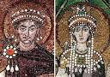
Mosaic in the San Vitale in Ravenna, Italy
- Notice the similarity of the crowns
- Think about how there was no separation between church and the government…
- This is why we see images of rulers in the churches

