Lesson #15
Guided Reading
Medieval Art

The Early Medieval Period- known or called a few different names
- Dark Ages- was thought to be a time of few accomplishments
  - Inventions/Accomplishments-
  - Parliamentary government
  - Common Law
  - Modern Language
  - Buildings
  - Illuminated Manuscripts
- The Age of Faith- the importance people of the time placed on religion in their daily lives and the church was basically governing the people

Charles The Great- Charlemagne
- King of the Franks
- Became first Holy Roman Emperor
  - Crowned by the Pope on Christmas Day in 800ACE
- Aachen- or Aix-la-Chapelle- is the present city in Germany where Charlemagne’s Empire was located

Feudalism- system where weak noblemen gave up a portion of their land as a way of paying strong lords to protect them against invaders and crusaders or people that went on quests to retrieve relics or holy objects to the Pope.

Churches and Monasteries-
- Transept- An aisle that cuts directly through the nave on side aisles of the church
  - This made churches in the shape of a cross
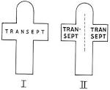
Imagine you are looking down in the church or viewing it from the sky. This is called an areal view. Do you see the cross shape caused by the transept?

- Cloister- an open court or garden with a covered walkway seen in monasteries and in churches

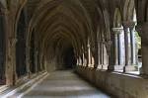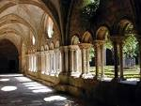

- Monasticism- type of life monks lived
  - Devoted to prayer and meditation

Art of the Medieval Period-
- Manuscript Illumination- created by monks to tell a religious story through both paintings and words
  - Delicate paintings
  - Accented in gold and silver

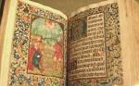
This is an example of “Manuscript Illumination”. Notice it is a book compiled of stories that have ornate and are delicately detailed of religious stories from the Bible.

  - Illumination- when something appears lit up or shiny and s created by using gold or silver leafing (very thin pieces of metal, thinner than paper)
  - Symbolism- used in Manuscript Illuminations
    - Symbolism refers to an image that stands for a deeper meaning or someone/something else.
      - The Four Evangelists: Saints Matthew, Mark, Luke, and John
      - St. Matthew= Angel or Man
      - St. Mark= Lion
      - St. Luke= Bull
      - St. John= Eagle
- This is an example of a Manuscript Illumination

- St. Matthew is depicted here

- We know it’s St. Matthew because the symbol for him is as a man or angel.

- He is also depicted writing in most images of him.
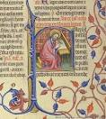

Conclusion/Main Points:
- The Catholic church was gaining power over the people and government
- Most art was commissioned by the Pope (head leader of the Catholic Church) or the Catholic Church
- Art that inspired and taught people of the Christian faith was the only art that survived or is recorded today

