Lesson #18
Guided Reading
Italian Church Paintings

Italian Churches- Gothic architecture did not become popular in Italy; therefore artists were commissioned to paint murals on church walls
- Artists were also commissioned to create religious scenes on wooden panels
- Triptychs- a three (3) paneled wood paintings that could open and close
  - Usually depicting a religious scene that was displayed in the church

Duccio di Buoninsegna- 1255-1318
- An Italian painter that was known mostly for his triptych paintings
- Painted mostly in Byzantine and Gothic styles

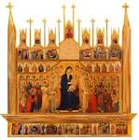
The Maesta
- Created in 1308-1311
- Tempera Paint on Wood Panel
- Depicts Madonna in the middle holding Jesus Christ
- Notice the angels on each side
- The left and right of Madonna and child is showing the life of the Virgin Mary

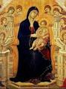
Do you notice anything that is out of place in the image?

The child, Jesus, looks like a grown person. It’s almost if the artist created a figure and shrunk him down to child size.

We see these type of figures when depicting children

Giotto di Bondone- 1266-1337
- Broke away from the flat style and painted more natural and sculpture-like figures
- Interested in painting realistically with true emotion
- First artist in Medieval Period to paint in a realistic style
- Uses mostly Fresco painting style

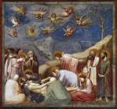
The Lamentation Pieta
- Created in 1305
- Depicts people mourning Jesus when he was crucified
- Notice the detail of the figures
- The figures are the main focus and the background is secondary
- Look at the positions of the figures. They are in more of a realistic in motion pose

Fresco- painting created when plaster is applied to a wall or surface and pigment or the paint is applied on top of the plaster
- The walls or surface you are painting on have to be wet with plaster
- Next, apply the paint while the plaster is still wet
- When the plaster dries, it seals the paint into the wall
- This makes the colors stay stronger and more vibrant longer

