Lesson #19
Guided Reading
A History of Renaissance to Modern

The Italian Renaissance- during the 15th Century
- Move away from Religious themes and focus on Humanism
- Influences that shaped the Renaissance include-
  - Ancient architecture from the Greek and Roman periods
  - Literature
  - Greco-Roman ideals

The Medici Family- wealthy bankers from Florence who supported the arts
- Paid artists to create works of art for the family
- Financed art throughout Florence, therefore, art was able to grow and be seen more

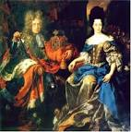
This image details members of the Medici Family

Take note of the style of the clothing of the Renaissance era

This is a typical painting that would be commissioned by the Medici Family

Humanism- a belief in the dignity and worth of the individual
- Came from Greco-Roman ideals
- Interest in art and literature of ancient Greece and Rome
- Johannes Gutenberg- German who perfected the printing press
  - Able to produce hundreds of books
  - Education became more accessible

Masaccio- @ 1401-1428
- Created depth through the use of…
  - Light
  - Shadow
  - Overlapping of figures
  - Linear Perspective
- Created the “Holy Trinity”

Linear Perspective- graphic system, which showed an artist how to create the illusion of depth and volume on a flat surface.
- Created by Filippo Brunelleschi
- Objects appear to recede (go into/get smaller)
- Gave artists the ability to paint/draw 3D objects on a 2D surface
- Converging lines recede to a vanishing point.

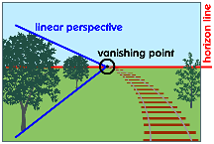
The following images give you a great idea of how linear perspective works in an artwork.

Vanishing point- the point at which you can no longer view the scene or an object. Where objects in an artwork vanish.

Horizon Line- usually where the sky meets the ground

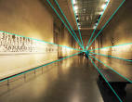

The Holy Trinity- painting of the crucifixion of Jesus Christ by Masaccio in 1428
- Example of linear perspective
  - Overlapping figures
  - The farther back in the painting the figures are, The Virgin Mary and John the Baptist, the smaller the figures are
  - Figures that are closer to the viewer, the two people on the outside of the columns who commissioned the painting, appear larger.
  - The columns that are closer to us are larger and get smaller as we stare into the painting
- Located in Santa Maria Novella
  - Church in Florence, Italy

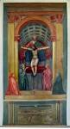
How would this be considered Linear Perspective?

What images or figures show us this is considered linear perspective?

Why would the artist include the people who commissioned the painting in this scene?

Arial Perspective- objects that are supposed to be in the distance are made smaller in size and duller in color.
- By adding the hue blue to the paint, it creates a foggy type mist that appears darker or further away.
  - Think of a mountain scene where the mountains in the back look blue
- Uses color to create depth
  - Color, hue, value and intensity are changed to create depth and distance in a painting
Aerial Perspective
Focus on the colors seen in this image

Notice how the colors at the bottom of the picture are more intense and crisp

Now, looking up the picture towards the clouds, notice how the colors become less crisp and more blue in hue.

The Tribute Money- created by Masaccio in 1427
- Example of Aerial Perspective
  - The human figures we see look realistic and are in a realistic environment.
  - Strong light makes the figures seem closer
  - Dull hues, tones, shades or colors appear on figures that are on the background, or further away.
  - Lifelike gestures and expressions make the figures seem real

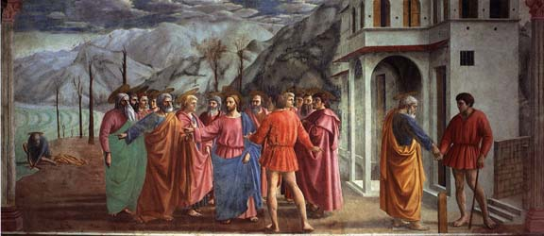

- About the Painting:
  - Middle of Painting- Jesus telling St. Peter he will find a coin in a fish’s mouth to pay the tax collector
  - Left Side of Painting- St. Peter finding a coin in a fish’s mouth
  - Right Side of Painting- St. Peter giving the coin to the tax collector

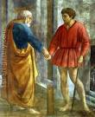
The image on the left is detailing the right side of “The Tribute Money”

St. Peter is on the left and the tax collector is on the right

A Blend of Gothic and Renaissance Styles- where an artist uses elements or aspects of both time periods, blending them together t create a unique style of their own.
- Two main artists who used these techniques: Fra Angelico and Lorenzo Ghiberti

Fra Angelico- 1400-1455
- Monk and painter from San Marco monastery in Florence, Italy
- Used linear perspective in paintings
- Inspired by a blend of Gothic and Renaissance styles
  - Does not show an interest in creating depth
  - Continues with religious scenes or stories that are more important to him than creating a realistic scene.
The Annunciation- Fresco Painting by Angelico in Florence, Italy @ 1440-1445
Notice how his painting skills are not the same as the other artists.

Only reference to linear perspective we see is with the columns

Main focus is on the human figures with little emotion or movement in their positioning
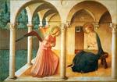

Lorenzo Ghiberti- 1378-1455
- Sculptor who used elements of the Gothic style as well as Renaissance innovations
  - Renaissance= overlapping figures to create depth, figures have expressive gestures and facial features or expressions and portrayed objects receding into space
  - Gothic= main focus of art is to show religious scenes
- Most of his work is found in the Baptistery of the Cathedral of Florence
- Contest for the Cathedral Doors- city council of Florence held a competition for artists to design the doors of the Cathedral
  - Ghiberti won
  - Spent twenty-one (21) years creating twenty-eight (28) panels for the doors

Gates of Paradise- created from 1425-1452
- Located in the Baptistery of San Giovanni, Florence, Italy
- Created by Ghiberti
- 10 square panels with religious scenes
- Gold plated= illuminated and “looks like the gates to heaven” ~Michelangelo

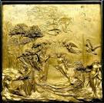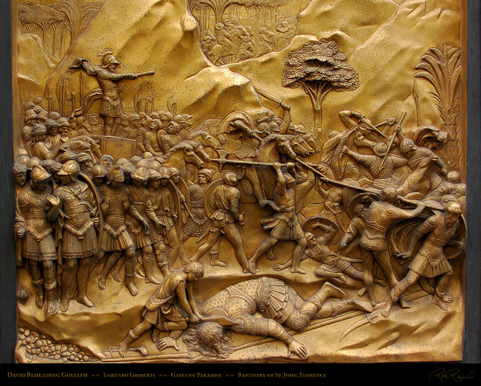
Here is a detail of a few panels seen on the Gate of Paradise. Notice how the Ghiberti used raised images to show how close the figures are. The recessed etchings show that the images are far away. This is aerial perspective in a sculpture
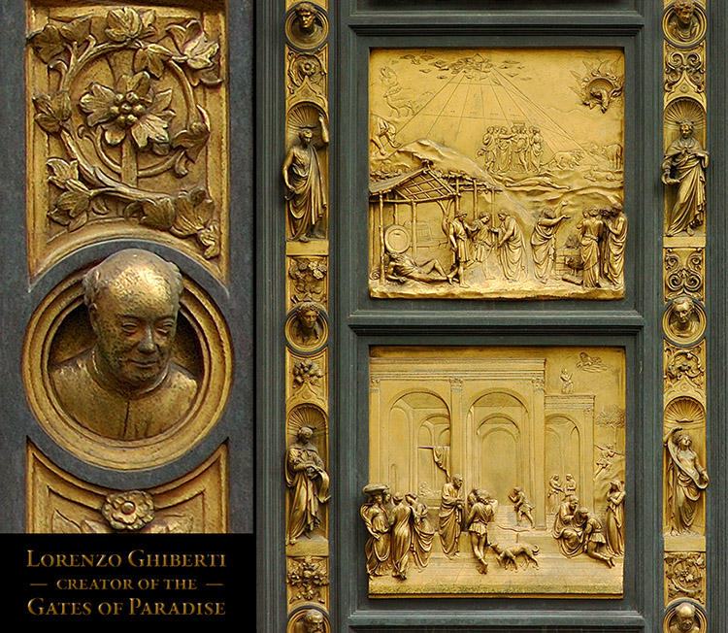
Look on the far left of the image…

The portrait is of Ghiberti, the artist that created the Gates of Paradise.

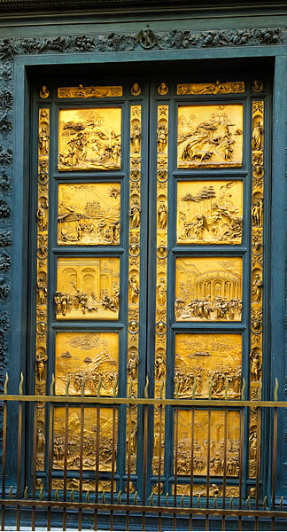
The Gates of Paradise

Notice how each panel has a different scene depicted

See how the doors are gold plated?

Why do you think the Ghiberti made the doors gold?

Key Terms:
- Capitol- the top area of a column
- Proportion- the size or scale of each element; think about one figure or aspect of the artwork as being one part to the whole artwork
- Proportion and balance during the Renaissance is usually symmetrical and focuses on realism

