Lesson #23
Guided Reading
The Renaissance in Northern Europe

Main Concepts-
- 15th Century, all painters in Northern Europe use the Late Medieval Style
  - @ 1500 Italian influence spread north
  - We see a huge shift in the style of art from the Northern European Artists

New Techniques Developed-
- Tempera paint- made of dry ingredients or pigments and a binder
  - Binder was usually made out of egg yolks
  - Type of paint that was primarily used up until the 15th century
- Oil Paint- paint that was made out of pigment and an oil base
  - Artists could add more detail because the paint dries very slowly as well as adding glazes that made the finish product look glossy or jeweled
- Italian painters used the fresco style- had to work quickly because the plaster had to be wet when they applied the pigment
- Gesso- a glue and white pigment that is used to seal or prime the canvas before you paint. Gesso without white pigment is like a glaze or gloss that seals in the pigment or color and gives a sheen or jewel like gloss
- Symbolism- when objects in an artwork or painting stand for a different meaning
  - Examples:
  - Dog=loyalty
  - Burning candle= presence of God
- Triptch- three paneled painting; usually has hinges and can open/close

The Flemish Artists-
- Jan van Eyck- @ 1390-1441
  - Credited for creating oil paint
  - Developed a new style of painting
  - “The Arnolfini Portrait”
    - Arnolfini means Wedding
    - Portrait of Giovanni and his wife, an Italian merchant in Bruges
    - Uses symbolism
      - Small dog= fidelity or loyalty
      - Single Burning Candle= God’s presence k
      - Mirror on back wall has a reflection of two different people
      - “Jan van Eyck was there” is written in Latin above the mirror with the date 1434
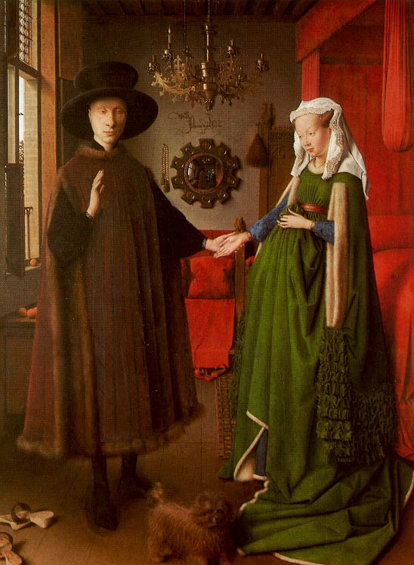
Symbolism-
This painting is known for having multiple meanings and objects that relate to symbolism.
- Dog=Loyalty
- Dress=Fertility; how the lady looks pregnant, but really is not
- Mirror= contrasting images seen inside

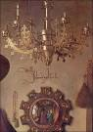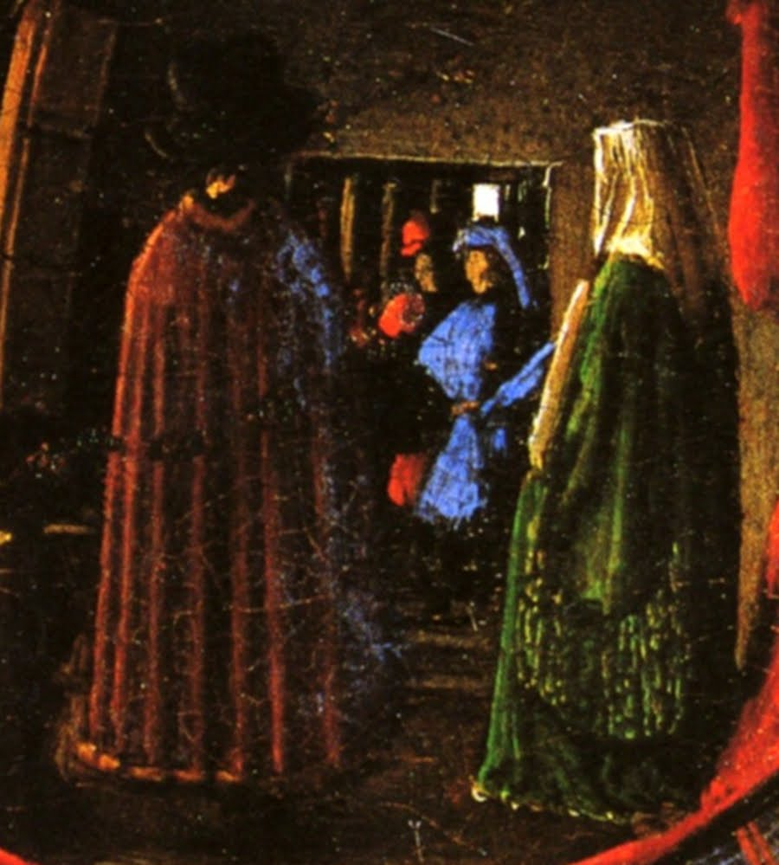
This is the image zoomed in that we see in the mirror. Notice how we see the back of the figures. We also see the hidden figures in blue and red. No on really knows who it could be
Here is an image of the word written on the wall…
“Jan van Eyck was there” written in Latin

Realism and Emotionalism- combined some of the emotionalism of the Gothic period with realistic elements to create a new painting style
- Rogier van der Weyden- @ 1399-1464
  - Created artworks that were concerned with the emotion of the characters as well as the arrangement of the figures
  - “Decent from the Cross”
    - Created @ 1435
    - Bodies of Christ and his fainting mother create an “S” shape
    - Figures are placed in a shallow nave or niche in order to draw the viewers attention to Christ

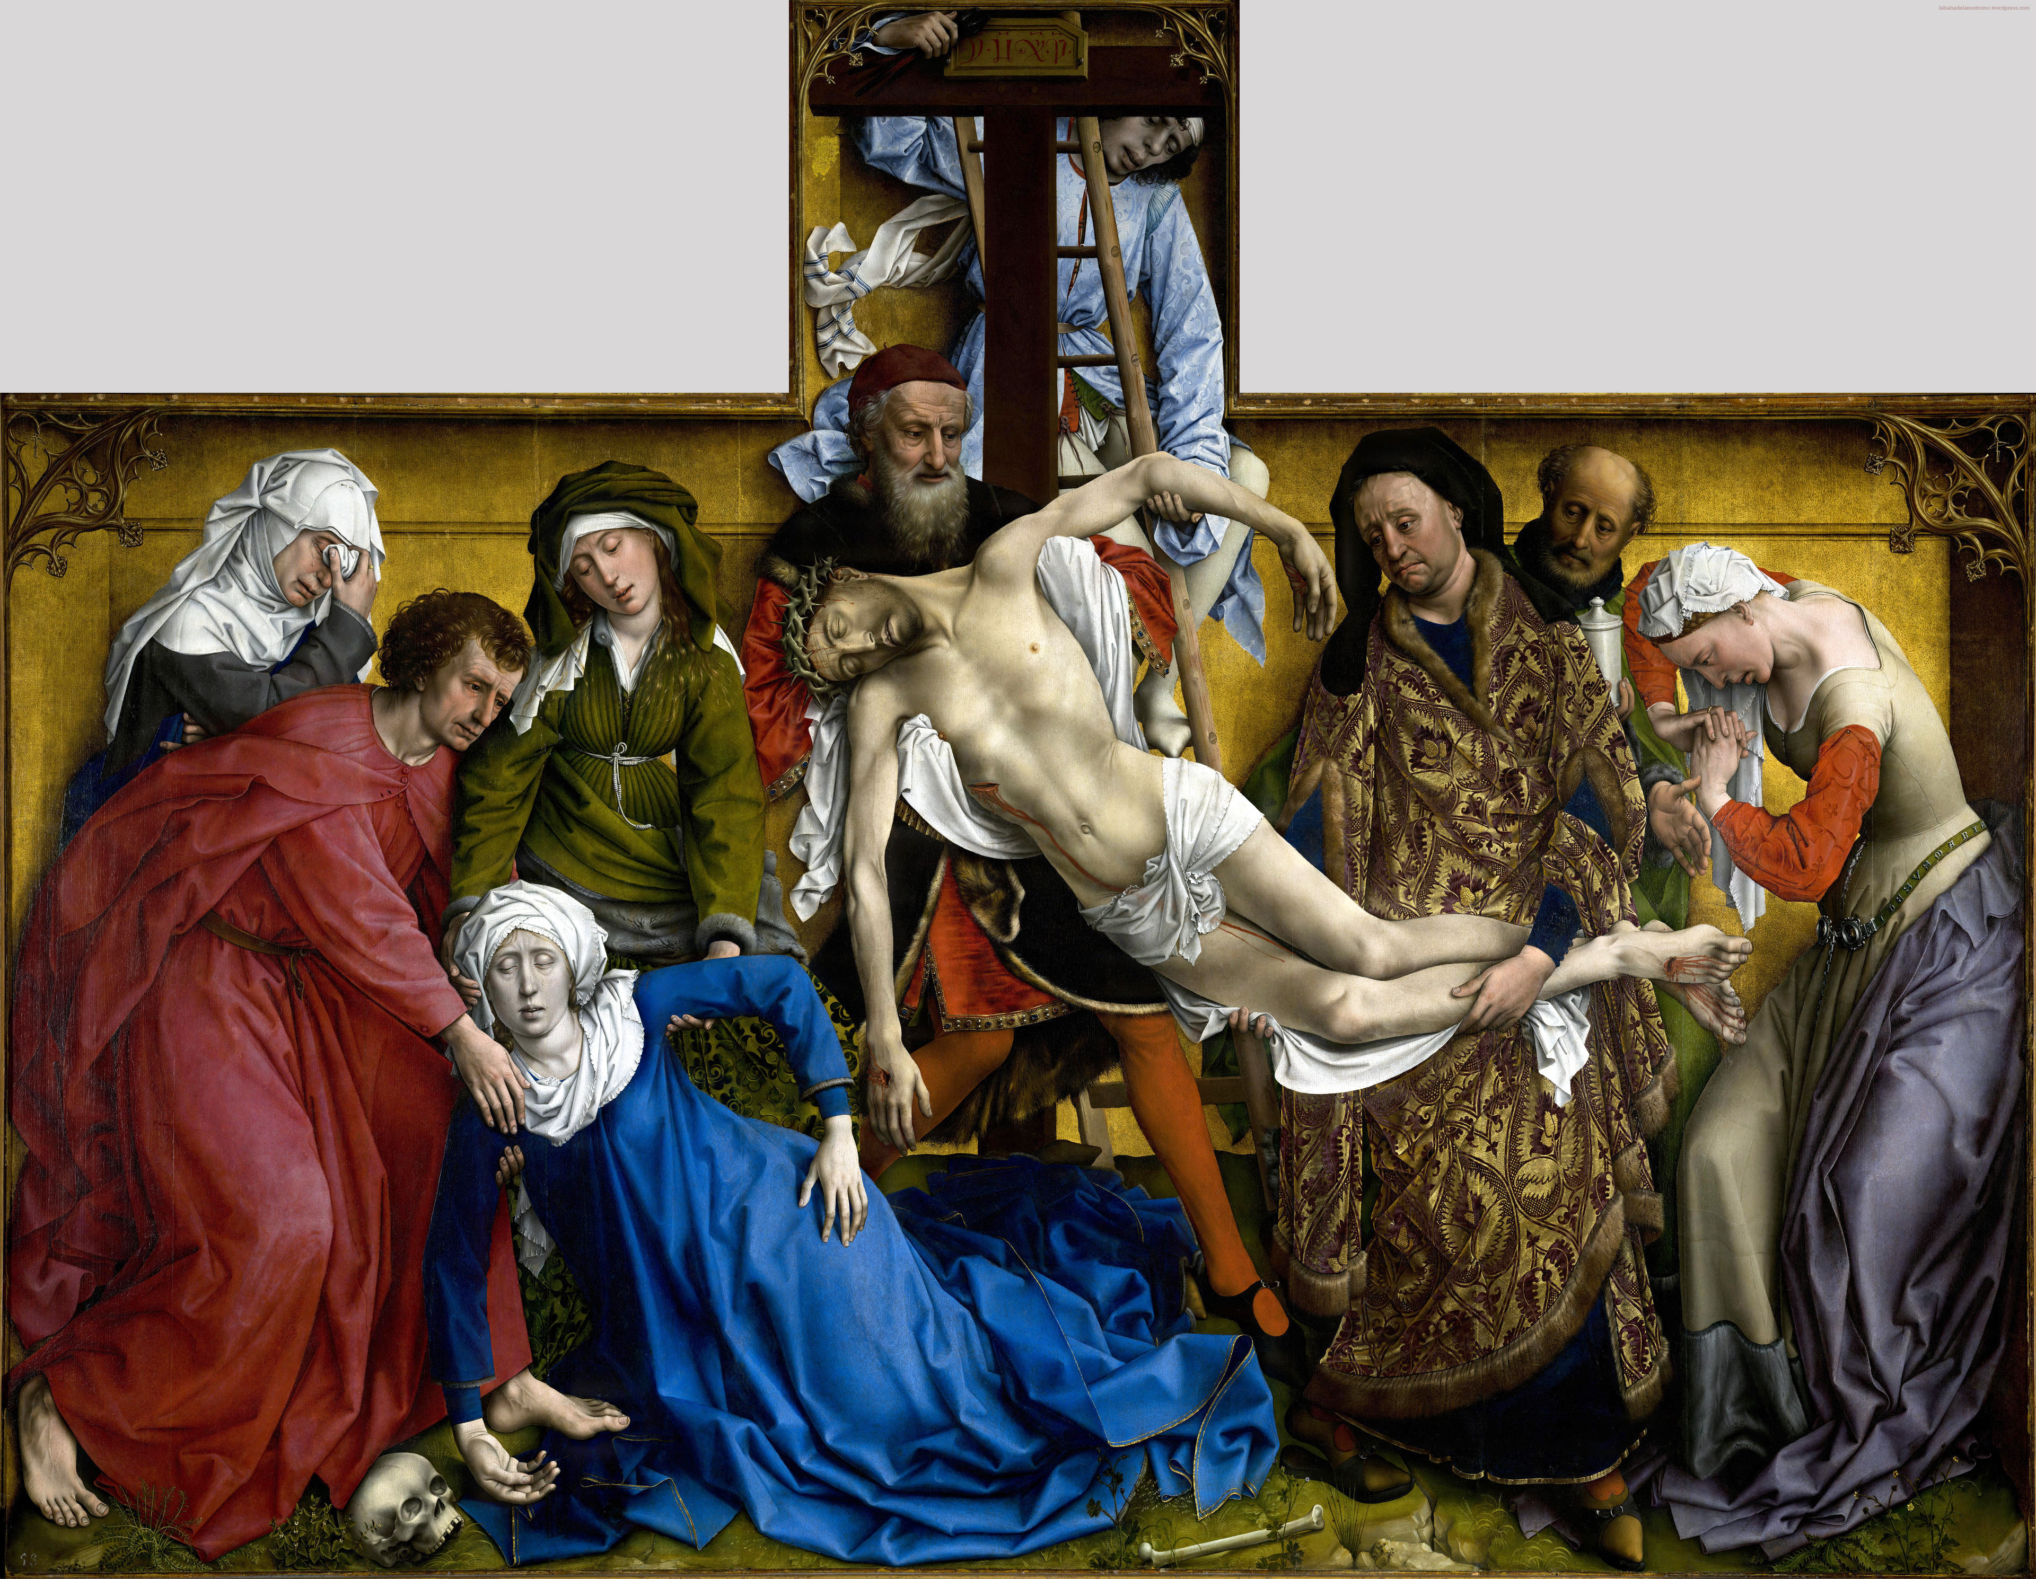

What do you think is more important in this painting… the people or the background?

  - Main difference between Eyck and Weyden-
    - Weyden- highly emotional and uses placement of figures to create a scene, more concerned with the emotion and placement of figures rather than details.
    - Eyck- serene style that is less emotional and focuses on the extreme detail in his paintings.
- Hugo van der Goes- @ 1440-1482
  - Used emotion like Weyden and extreme detail like Eyck
  - Created his own style by contorting the size and scale of figures to add symbolism and an expressive mood.
  - “The Portinari Alterpiece”- @ 1476
    - The center panel in the tryptch is called “Adoration of the Shepherds”
    - Uses proportion and movement in this scene
    - Figures are in different sizes and positions
    - The placement of the figures draws our eyes back into the painting as we look from face to face
    - The floor seems tipped up towards us, making us feel we are a part of the painting
    - Faces of the three (3) Shepherds- wide-eyed admiration contrasts with everyone else’s solemn/straight faces.
      - The use of peasants for the central role
      - Direct emotional response to the scene

