Lesson #24
Guided Reading
The Art of the Sixteenth-Century Europe

Venetian Art-
- Used a Byzantine sense of color and light in artwork
- Not concerned with the depiction of architectural space
- Linear Style- composition is based on clear lines

Giorgione da Castlefranco- @ 1477-1511
- One of the first Venetian painters
- Used landscapes as an important aspect of his work, landscapes creates a stage for his artwork
- Used oil paint to depict rich color

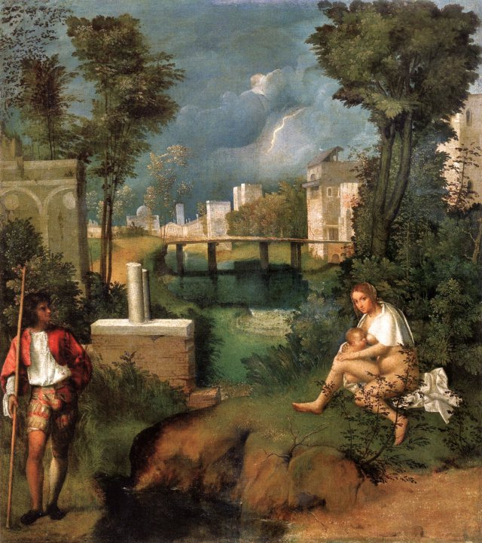
The Tempest: @ 1505
- Landscape is the most important part of design rather than the people
- Create a lyrical, dreamlike scene
- Starts a new tradition in painting because we’re focusing more on landscape rather than portraits or people

Titian- @ 1490-1576
- Combined landscapes and oil paints
- Figures show more movement and activity
  - Twisting and turning movements that show they are alive and have spirit
- Avoided hard edges when painting
  - Figures or shapes blended into the background
- Famous for portraits of the Royal Family

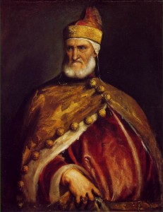
“Doge Andrea Gritti”
- Created by Titian @ 1546-1548
- Doge- means ruler of Venice
- Used a Painterly Style- painterly means patches of color are used to create the image. There is no hard edges or lines (opposite of Linear Style) Artist uses quick brush strokes with soft edges.
- Evokes a feeling of power by the heroic position the Doge is in as well as his clenched hand

Mannerism-
- The art movement that occurred during the Protestant Reformation
  - Protestant Reformation- religious movement started by Martin Luther against the Catholic Church
    - Why we have different sects of Christianity ex. Methodist, Lutherans, Baptists etc.
    - Broke away from Catholic Church in hopes of creating a more pure form of Catholicism
    - As a result, people during this time were uneasy and experienced chaos in Italy because their way of thinking/practicing their religion was challenged
- Mannerists distort reality by…
  - Elongation of figures
  - Exaggeration
  - Changing the perspective
  - Asymmetrical balance
    - Asymmetry- used in order to pull away from the classical feeling of balance. Asymmetry gives an artwork a restless feel
Tintoretto- @ 1518-1594
- Combined the Venetian Style and the use of color to create qualities of Mannerism
- Real name= Jacopo Robusti
- Goes by Tintoretto because his father was a dryer and “Tintoretto” means little dryer
- Uses strong pattern of light and shadow with quick painterly brush strokes.
- Artworks by Tintoretto were used by the Catholic Church to help with the counter reformation
  - Counter Reformation- the action(s) the Catholics took in order to not loose church members during the Protestant Reformation
    - Religious movement that was suppose to keep Catholics from turning to Protestantism

El Greco- @ 1541-1614
- Real name= Domenikos Theotocopoulos
- Originally from Greece
- El Greco in Spanish means “the Greek”
- Greek mannerist painter that lived in Spain

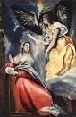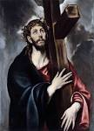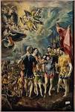

Why do you think El Greco and Tintoretto changed their names? Or went by a nickname as an artist?

_________________________________________________________________________________________________

_________________________________________________________________________________________________

_________________________________________________________________________________________________

