Lesson #25
Guided Reading
Northern Renaissance

Matthias Grunewald- @ 1480-1528
- Artwork shows the use of both Renaissance by using perspective and powerful figures as well as Late Gothic Style
  - Images were powerful by having a lot of color and an emotional approach
Emotional approach to depicting the crucifixion:
- Portrays agony by having the figures to the sides of Jesus being a part of the scene
- Color adds intensity
- Composition, brushstrokes and color add to the feeling of anguish and sorrow
**This is the opposite of the Renaissance**
- Renaissance showed calm and balanced compositions, Grunewald does not.

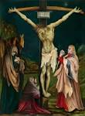

Above image: “The Small Crucifixion”
By: Matthias Grunewald
@ 1510

Albrecht Durer- @ 1471-1528
- Print-work artist that was inspired by the Renaissance
- Considered one of the first artists to show an interest in painting self-portraits
- Studied Grunewald
  - Didn’t like how Grunewald’s artwork didn’t have as much balance or rational order as the Renaissance had
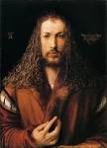
“Self-Portrait in a Fur Coat”
- @ 1500
- Not typical of artists to create self-portraits
- Renaissance inspired design
  - Use of light
  - Symmetrical balance
  - Figure is still, calm and serene
  - Dark stagnate background
  - Use of a light source makes image look like a statue
Albrecht Durer Continued-

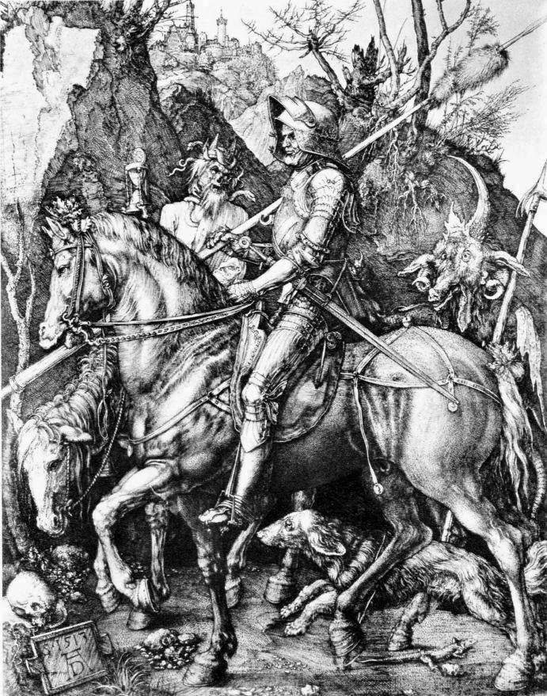
“Knight, Death and the Devil”
- Engraving
- @ 1513-1514
- The Knight and the horse are depicted as classical figures having a solid form similar to Renaissance
- Represent faith and courage
- Dog is used to represent loyalty (symbolism)
- Creatures surrounding the knight= death and the devil
- Gothic Style= because of the fanciful creatures

Hieronymous Bosch- @ 1450-1516
- Painter of the late 15th and early 16th centuries
- Artwork is similar to the Italian Mannerists
  - Reflected the tensions people felt during the time period
- Used symbolism to convey a message or idea
- Artwork had a central theme of good versus evil
- Included some elements of humor in his artwork

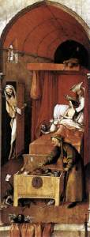
“Death and the Miser”
- @ 1485-1490
- Oil on a Wooden Panel
- “Death” is knocking on the miser’s door
- Uses humor because the miser, on his death-bed is unable to be able to choose between money and placing his faith in the Lord.
- The element of a quick decision is what Bosch is trying to convey

Pieter Brugel- @ 1525-1569
- Flemish Painter inspired by the artworks of Bosch
- Used parables to convey a story
  - Parable- story with a symbolic message
- Most of his characters choose not to take the “road to salvation”

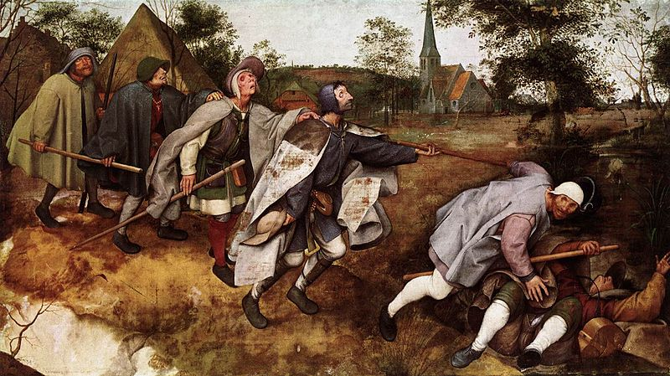

“The Parable of the Blind”
- Created in 1568
- Reference to the Biblical quote from Jesus “And if the blind lead the blind, both shall fall into the ditch.”
- Depicts characters who do not take the road to salvation or who do not do good
- Brugel’s point was that anyone can be misled

Hans Holbein- @ 1497-1543
- Originally from Germany
- Left to become the Court Painter for King Henry VIII
- Best known for portraits of the royal family
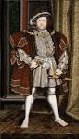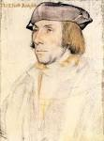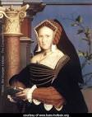
King Henry VIII Sir Thomas Eliot Lady Mary

