Lesson #28
Guided Reading
Spanish Art

Jusepe de Ribera- @ 1591-1652
- One of the first Spanish painters to use realism
  - Naturalistic approach
- Influenced by the work of Caravaggio
  - Used chiaroscuro in their artworks- the use of shadows and a strong light source

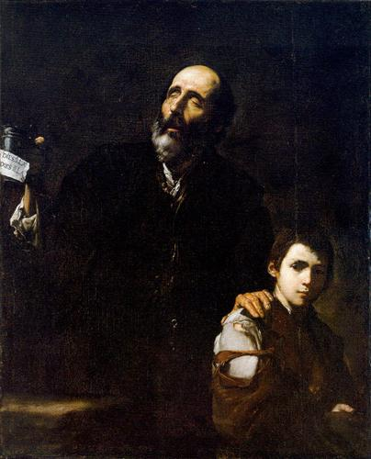
The Blind Old Beggar
- @ 1632
- Oil on Canvas
- Painting may be related to the popular tale of time
- Also could be commissioned or donated to a Christian Charity because the parable of the blind beggar

Diego Velazquez- @ 1599-1660
- Considered one of the best artists of the Baroque Period
- Born of noble blood
  - Family did not want him to become an artist because it was not fitting for a man unless he became an artist for the Royal Court
- Became an artist for the Royal Court of King Phillip IV
  - Painted portraits of the family
  - Painted King Phillip IV over thirty (30) times
- In his early artworks, Velazquez painted in the Caravaggesque Style- where artists use light and dark dramatically
- Overall, Velazquez mainly focused his subject matter on portraits, genre and still-life’s rather than religious themes
  - This was a total change in subject matter for Spanish Artists @ the 17th Century

Diego Velazquez Continued-

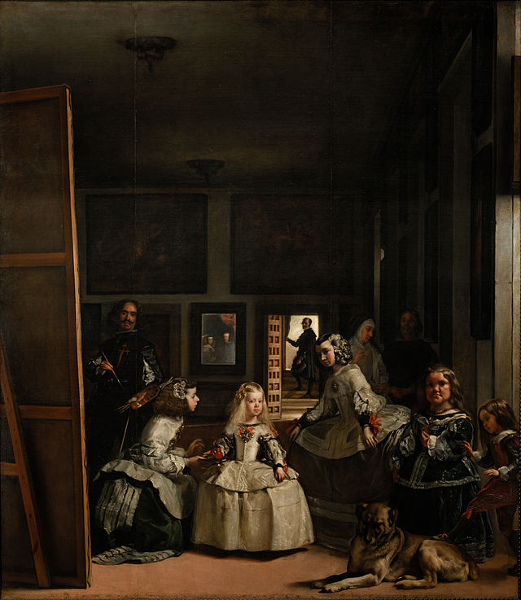

Las Meninas- @ 1656
- Las Meninas means the maids of honor
- Use of dark shadows the further you look back into the room/scene
- The closer you look at the scene, the more details you find
  - Velazquez is in this painting on the left hand side, painting a portrait in his own painting
  - Check out the man in the doorway
  - If you see the mirror in the center of the painting, you will notice the King and Queen’s reflection

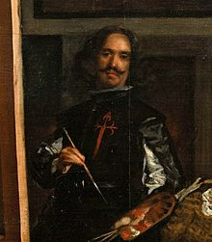
- The image on the left is a zoomed in image of Velazquez in the above painting
- The little girl in the painting was painted by Velazquez numerous times during his career as the Royal Court Painter
Bartolome Esteban Murillo- @ 1617-1682
- Artist who worked mainly in monasteries and convent in the Seville area
  - Unlike Velazquez and Ribera because he focused on Religious themes

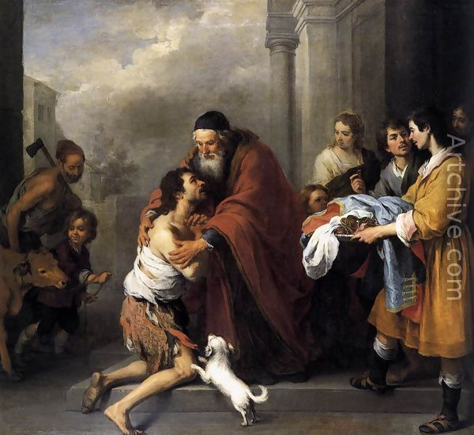
Return of the Prodigal Son
- @ 1667-1670
- Prodigal- means a reckless or wasteful person
- Scene is based on a biblical parable, or story.
- The prodigal is the son in the painting who returns to his father’s welcoming arms.
- What do you think the son did that was so bad?

Dutch Art Spanish Art
- Religious paintings were commonly the subject matter
- Around the 17th century, artists started painting realistically
- @ 17th Century, artists painted the royal families
- Artists had freedom with subject matter by the end of the 17th century
- Genre paintings
- More focused on daily life
- Looks as if we’re looking in on a scene that we’re not suppose to see

