Lesson #30
Guided Reading
Art of England and Spain
New Styles in 19th Century Art Neo-Classicism

William Hogarth- @ 1697-1764
- Subject Matter: Local people he saw in taverns and on the streets
- Modern Moral Subjects- a type of morality at play; meaning he loved to expose the foolishness of how people behaved and the immoral conditions of the time period
- Preferred to paint common people rather than the aristocracy

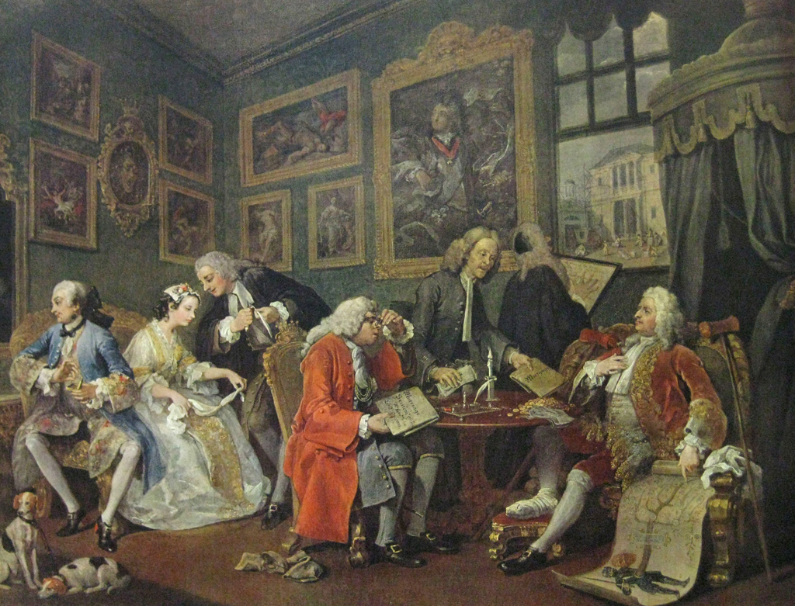

Marriage a la Mode
Created: 1742-1744
By: Hogarth
- Famous series of paintings that depict the contract of marriage
- This is a foolish behavior by royals because the unity of marriage was a contract that either united two countries and formed alliances OR it was to “get rid of” a daughter by giving the husband and his family money to marry.
  - This is where a “dowry” comes from and why the woman’s family is suppose to pay for the wedding
Portrait Paintings- popular with the aristocracy in England during the 18th century
- Came about because of the Protestant Reformation
  - The Church reformers were against the use of religious images
  - Portrait painting became popular with the growing aristocracy
- Nobles or wealthy upper class peoples would commission or hire artists to create portraits of themselves, their family, etc.

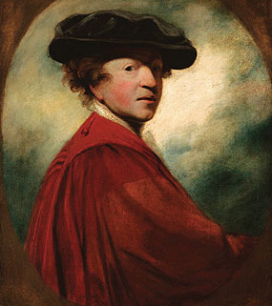
Sir Joshua Reynolds- @ 1723-1792
- One of the more popular portrait painters during the 18th century

Picture to the left:
- Self-Portrait of Reynolds

Thomas Gainsborough- @ 1727-1788
- Painted portraits for King George III and his queen
- Received many royal commissions because he worked with the King
  - Became the royal families favorite painter

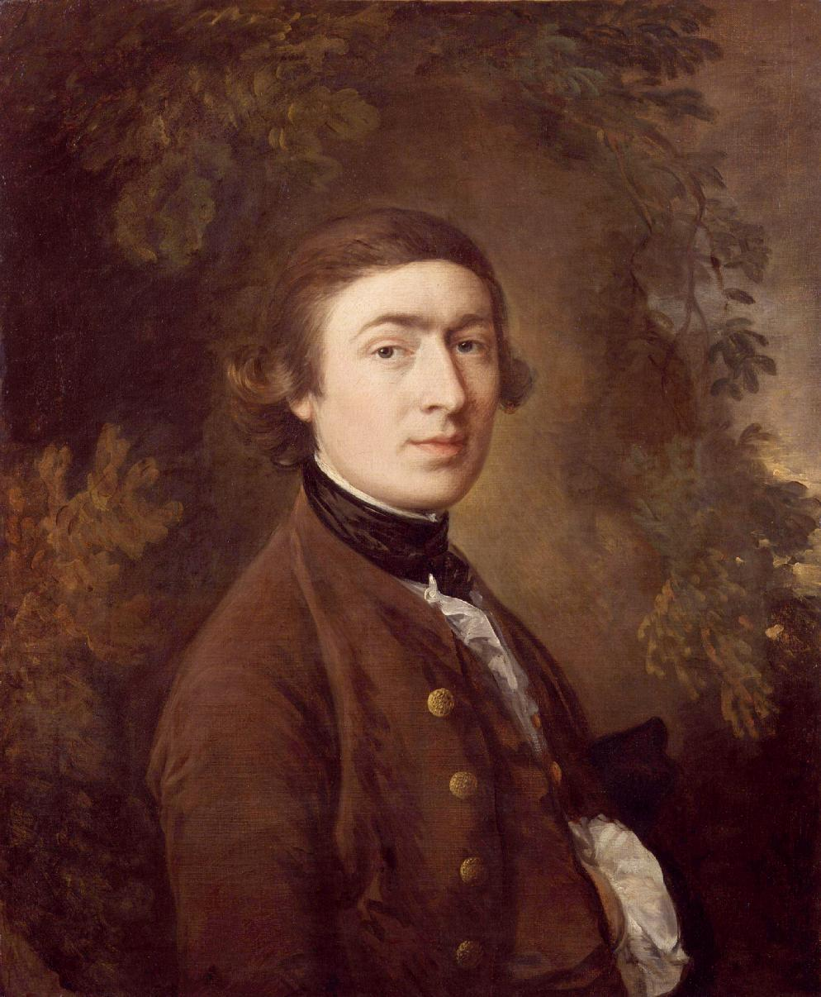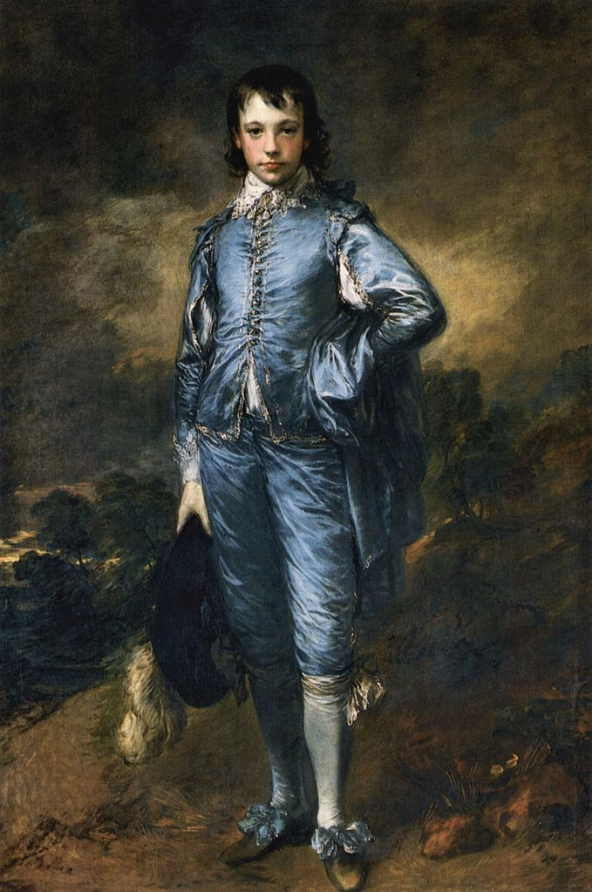

Self-Portrait of Gainsborough Jonathan Buttall: The Blue Boy
By: Gainsborough By: Gainsborough
Created: 1759 Created: 1770

Sir Christopher Wren- @ 1632-1723
- Known at first for being an accomplished architect
  - Designed many of the buildings in London
    - St. Paul’s Cathedral was designed by Wren and is located in London
- Influenced by the Italian Renaissance and the Baroque Periods
- Great Fire of 1666- Fire that burned down and destroyed most of London
  - Burned for four (4) days
  - Destroyed 89 churches
  - Destroyed 14,000 homes
- Wren was named by the royal commission to rebuild most of the city

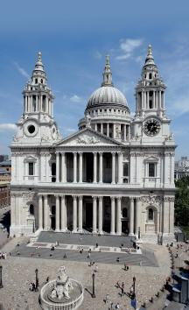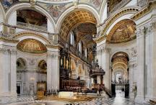

Above: The images above are of St. Paul’s Cathedral located in London England. Notice how the columns are reminiscent of the Greek Classical Period being Iconic Style. The Italian Renaissance also inspires it by having a large dome. The interior is more elaborate and embellished.

Francisco Goya- @ 1746-1828
- Spanish artist
- First style resembled the Rococo style
  - Painted for the Spanish King Charles IV and created portraits of the royal family
- Switched styles, now painted like the artists Velazquez and Rembrandt
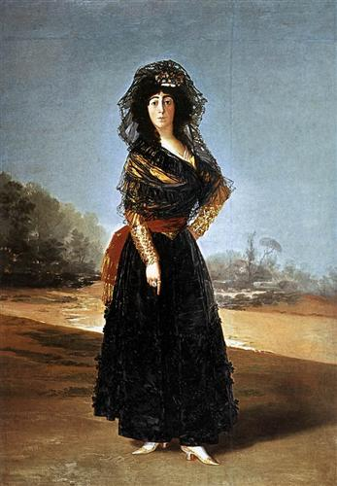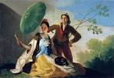
The Parasol
Created: @ 1777
By: Goya
The Duchess of Alba
Created: @ 1797
By: Goya

The Family of Charles IV
Created: 1800
By: Goya
- The Royal family is gathered to watch Goya paint them
- The royal family isn’t depicted as being idolized.
- Goya painted them as if he didn’t like them or he wasn’t happy to paint them
- Goya is seen on the far left by the canvas
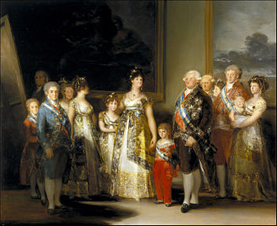

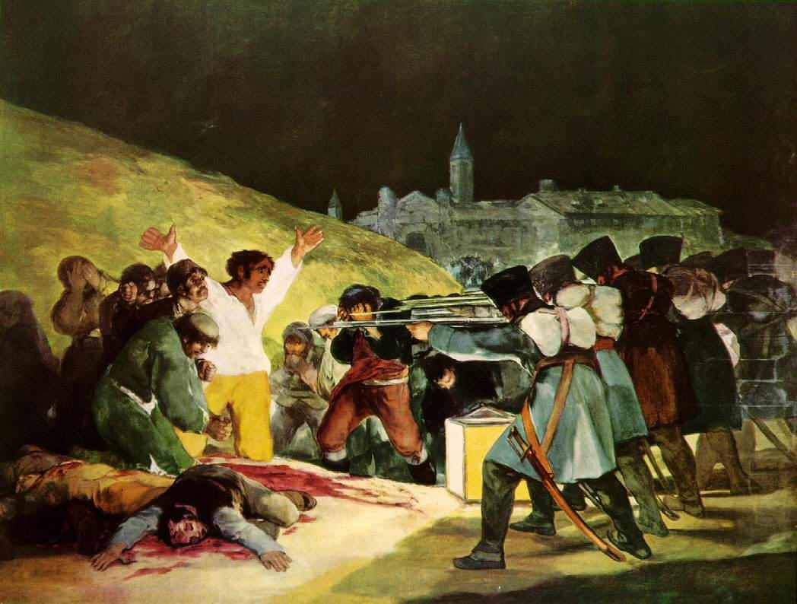
The 3rd of May, 1808
Created: 1814
By: Goya
- Subject Matter: French Suppression of Spain
- Most famous painting by Goya
- The people on the left are from Spain and the people on the right are French Revolutionists
- Dramatized by the use of light

Vocabulary:

Academies- Schools that taught art with emphasis on ancient classics

Salons- Annual Parisian (Paris) exhibitions of artwork. Extremely elite and only accepted the most popular or socially acceptable works of art

Death of Marat- a painting created by Jacques-Louis David that depicts the assassination of French Revolutionary Leader.

Intelligentsia- intellectuals who form an artistic, political or social vanguard (basically a club for social elites that have the same views)

