Lesson #31
Guided Reading
Romanticism and Realism

Romanticism- style portrayed exotic and dramatic subject matter
- Attempt to create more natural and dramatic works of art
- Inspired by medieval stories that were written in Romantic Languages, Historical Tales, Literature, and travel to exotic lands
  - Romantic Languages- Languages that derived from some form of Latin
    - Ex. French, Spanish and Italian
- Response to Industrial Revolution in Europe
  - Every good was mass produced, which made artists turn away from mass produced art
- Romantic Artists Include…
  - Gericault
  - Delacroix
  - Constable
  - Turner

Theodore Gericault- @ 1792-1824
- Helped give birth to the movement of Romanticism through use of his dramatic and exotic subject matter

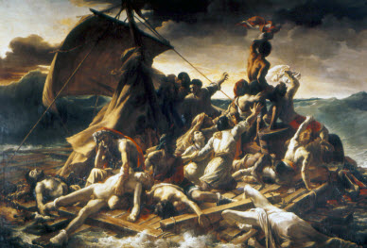

The Raft of Medusa
- Created: @ 1819
- An example of Gericault’s early form of Romanticism
- Based upon a true-story of a shipwreck at sea
Eugene Delacroix- @ 1798-1863
- The most iconic of the Romantic painters in France
- Used quick brushstrokes and patches of color like Paul Reubens
- Color was important aspect of his artwork
- Started a painting in the center of the canvas and worked his way outward to the edges
- Style of Delacroix can be described as swirling action and glowing colors
The Massacre of Chios

- Created @ 1824
- Depicting a war scene from the Greek War of Independence from the Ottoman Empire
- Most famous artwork by Delacroix
- Wasn’t about the actual event, but tried to tell the truth
- Many people felt the work was controversial because it didn’t depict a heroic act or event like traditional history paintings
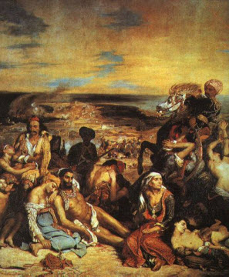

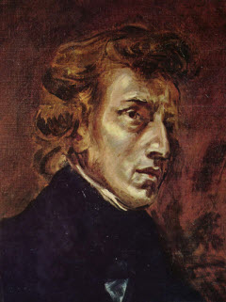
Frederick Chopin

- Created @ 1838
- Portrait of famous composer
- Painted from the center of the canvas, so starting with the face, and moving onto the background or edges of the painting
John Constable- @ 1776-1837
- Wanted to paint the landscape based upon the observation of natural effects
- Mostly landscapes of the English countryside

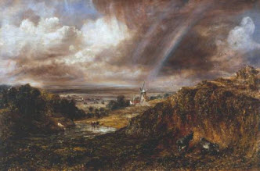
Hampstead Heath with a Rainbow
- A scene of dramatic effects of the change in weather
- Notice how you can almost see the air?

Joseph J.M. Turner- @ 1775-1851
- Was less interested in depicting nature realistically and more interested in showing the effects of light on a subject
- Used washes of paint to create atmospheric effects
  - This gradually made his work more and more abstract
  - Atmospheric effects- when an artist uses very thin layers of paint to make it look like there is a mist or show the visual volume of air
Snow Storm-Steam-Boat off a Harbor’s Mouth

- A View of Nature at it’s most violent
- People didn’t appreciate that Turner was trying to recreate formless things like the wind, speed and the whole atmosphere during a storm
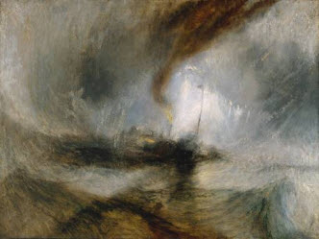
- Can you see the form in the middle of the canvas?
- Can you tell it is suppose to b a boat?
- Why do you think Turner kept painting like this even though people didn’t like his artwork?
Realism- Scenes from everyday life as they actually looked
- Realism Artists Include…
  - Courbet
- Realistic Artists paint like Hugo van der Goes
  - Use same imagery/subject matter in their paintings
  - Paint familiar scenes from everyday as they really look to the naked eye.

Gustave Courbet- @ 1819-1877
- Painted scenes of everyday life
- Found virtue or worth by painting scenes that were a closely observed phenomena or common scene/activity
The Stone Breakers

The First painting Courbet made in the Realism Style

What is the biggest difference between The Stone Breakers and Snow Storm-Steam-Boat off a Harbor’s Mouth?

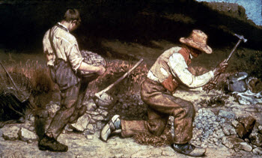

Artists who used Characteristics of both Realism and Romanticism:
- Manet
- Bonheur

Edouard Manet- @ 1832-1883
- Dedicated to “Pure Painting”
  - A system of painting patches of color to create an image
- Painted outdoors
  - So he could portray strong contrasts instead of shading
  - How images looked in harsh sunlight
- Manet’s artwork was refused by the Salon
  - Opened a special art exhibit called “Salon of the Rejected”
  - Special exhibition for artists whose works were refused by the regular Salon
  - Put on in 1863

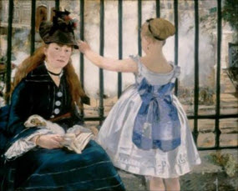
The Railway
Created: @ 1873
Focused on paint application:
- Some areas the paint is dribbled on.
- Other areas the paint is applies smoothly
- Subject Matter is painted as if you are gazing onto a realistic scene, not posed

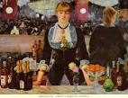
A Bar at the Folies-Bergère

Created: 1881-1882

Painted a scene of the bartender at the bar in her most realistic element

Rosa Bonheur- @ 1822-1899
- Raised during the time that women were not allowed to attend the traditional art school “Ecole-des Beaux-Arts”
- Interested in using animals as her subject matter
- 1865- First woman to become a member of the French Legion of Honor

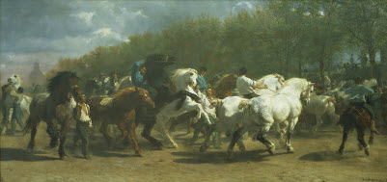
The Horse Fair
Created: 1853-1855

