Lesson #33
Guided Reading
Europe and America in the Late Nineteenth Century

The Post Impressionists: 1880-1890’s
- French art movement after the Impressionist Movement
- Post-Impressionists felt that the Impressionists were not concerned enough with solid forms in their artwork
  - Remember: the Impressionists were only concerned with showing the atmosphere; trying to make their work appear to have volume in the air and the effects of light on an object rather than the object itself.

Paul Cezanne- @ 1839-1906
- Beliefs and Characteristics of Artwork-
- Believed that the Impressionists were concerned with the look of the fleeting moment
- Impressionists neglected the solid forms of nature
- Represented Still-Life in his paintings
- Wanted to paint like the Romantic Period
  - Searched for balance in forms and color
- Often times distorted the perspective to created the illusion he wanted
- Developed a feeling of depth and solidity
- Created a separate surface or plane
  - Plane- separate surface or part in a 3D space
- Used Value, Line, Variety and Color to create a unified design

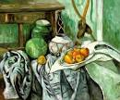
Still Life with a Ginger Jar and Eggplants

Created: @ 1890-1894

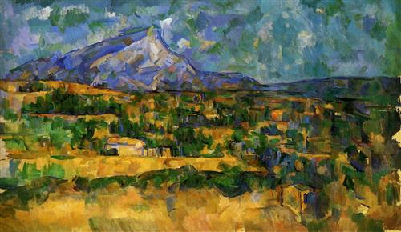
Landscapes Mont-Sainte-Victoire

Created: @ 1906

Vincent van Gogh- @ 1853-1890
- Characteristics of Artwork
  - Early Artwork-
    - Often in brown tones
    - Depicted the daily lives of peasants
  - Later Artworks-
    - Began to use more color
    - Short brushstrokes
    - Thick application of paint
    - Used pure colors, not mixing them, and applied directly to canvas
    - The viewers eyes were suppose to mix the colors
    - Use of color was meant to show excitement and express his inner feelings
  - Inspired by Japanese artists
    - Used bright colors
    - Applied them in flat patterns

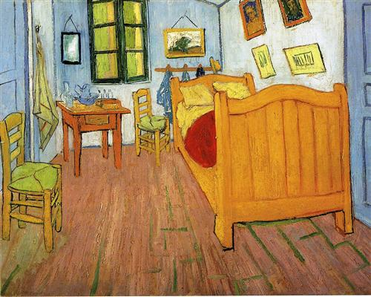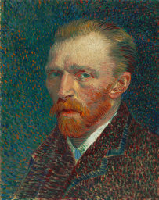
Bedroom at Arles @ 1888 Self-Portrait @ 1887
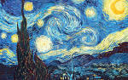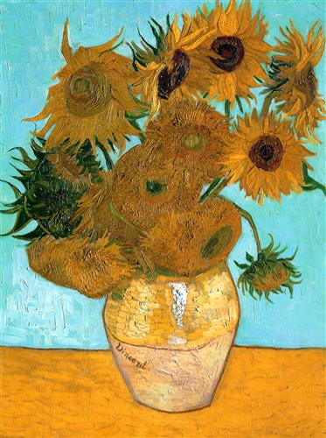
A Starry Night @ 1889 Sunflowers @ 1889
Paul Gauguin- @ 1848-1903
- Beliefs-
  - Impressionists were missing a direct and simplified approach to painting
- Subject Matter Included-
  - Primitive people
  - Unexplored lands
  - Searched for a simple life, free from distractions
  - Exotic
  - “I shut my eyes in order to see”
- Traveled to find subject matter
  - Started in Brittney, France
  - South France
  - Sailed to Tahiti
  - Worked in Polynesia for the rest of his life

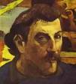
Self-Portrait of Paul Gauguin

Henri de Toulouse-Lautrec- @ 1863-1901
- Subject Matter-
  - Theatrical nightlife
  - Bohemian lifestyle of Montmarte (an area on the hill above Paris frequented by artists and writers)
- Inspired by Degas
  - Had a lifestyle focus
- Fun Fact- Lautrec was a dwarf due to health conditions

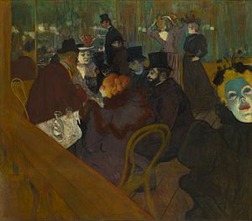
At the Moulin Rouge

Created: @ 1892

America in the Late 19th Century:
- What was happening in the US- (Industrial Revolution)
  - Country as expanding West (towards California)
  - Growing rapidly in population and wealth
  - Immigrants brought skills and knowledge
  - New inventions- typewriter, sewing machine and electrical lamp
  - Andrew Carnegie, J.P. Morgan and Nelson Rockefeller- wealthy businessmen who were lead players in promoting human wealth and welfare
    - Philanthropy- sharing wealth to promote human welfare

American Realism-
- 1st Realism painters was Thomas Eakins and Winslow Homer

Winslow Homer- @ 1836-1910
- Born in Boston, Massachusetts
- Mostly Self-Taught Painter
- Became known as the most important painters in America during the 19th century

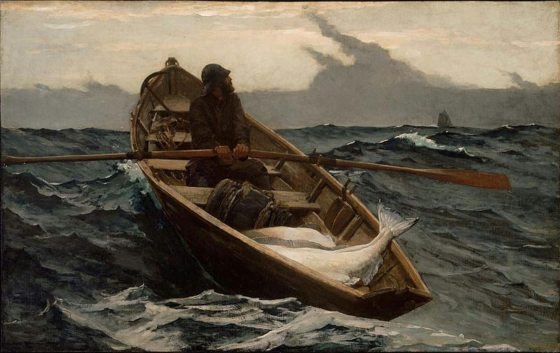
The Fog Warning

Created: @ 1885

Thomas Eakins- @ 1844-1916
- Born in Philadelphia, PA
- Inspired by- Courbet, Manet, Rembrandt and Velaquez
- Always painted in a realistic style for 40 years
- Subject matter was in his home-town, Philadelphia

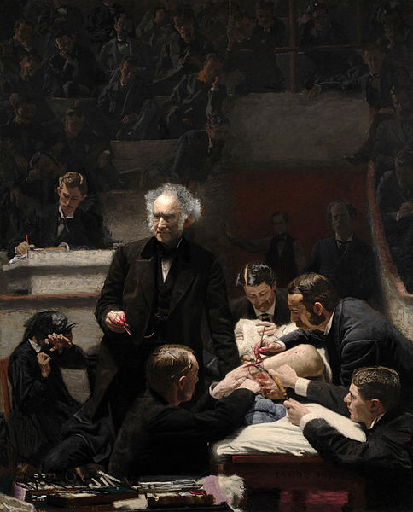
The Gross Clinic

Created: @ 1875

