Lesson #36
Guided Reading
Modern Art Movements to the Present

What was happening in the world…
- World War I was going on (1914-1918)
  - “Lost Generation”- Many of those who fought were “lost”, killed or wounded became deeply hurt and cynical about the morality of the society
  - This war was suppose to “end all wars”
  - These people who did come back went on to become artist and writers in order to depict their experiences during the war
    - Ernest Hemmingway, Fitzgerald and Remarque

Dada Art- means “anti-art”
- Group of artists who believed that nationalism and colonialism were the rots of World War I
- Felt that conformity to society led to the destruction caused by the war
- Dada art ignored culture and was intended to offend people, rather than comfort

Marcel Duchamp- @ 1887-1968
- Most famous Dada Artist
- Uses gradation of colors in nude descending stair case be the light and dark parts together look as if they are separate and moving in all directions
- Ready-Mades- “created” by Duchamp and were essentially found objects that he signed and called it art
  - Many of these objects he deemed had no aesthetic appeal.

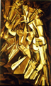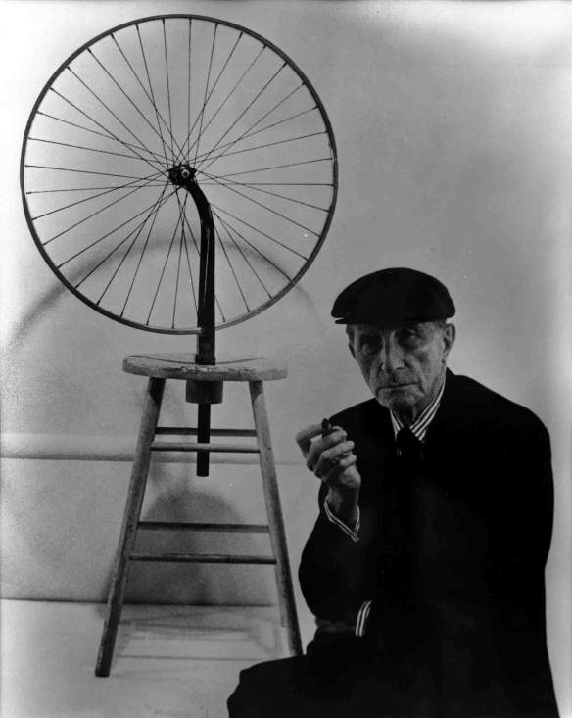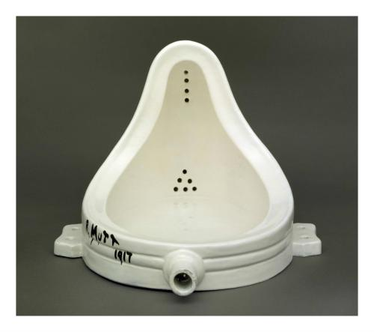
Left: Nude Descending a Staircase
Middle: Duchamp kneeling next to his “artwork” Bicycle Wheel
Right: “R. Mutt” A urinal sitting in a different position that Duchamp inscribed the name “R. Mutt 1917” on and called it a work of art
Surrealism- art in which the subject matter is derived from dreams, fantasy and the subconscious and serve as inspiration for the artist
- Ordinary objects in an unordinary setting OR Unordinary objects in an ordinary setting
- Salvador Dali played a huge role in Surreal Artworks

Salvador Dali- @ 1904-1989
- Mainly known for his surreal works of art
- Studied art in Madrid, Spain
- Most famous painters of surreal artists
- Most famous artwork is “The Persistence of Memory”

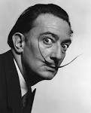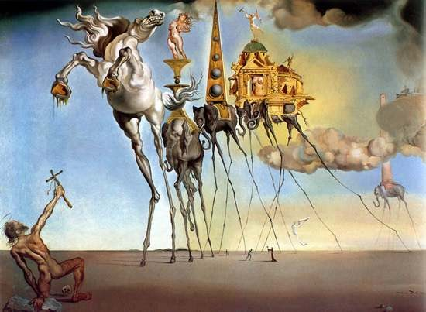

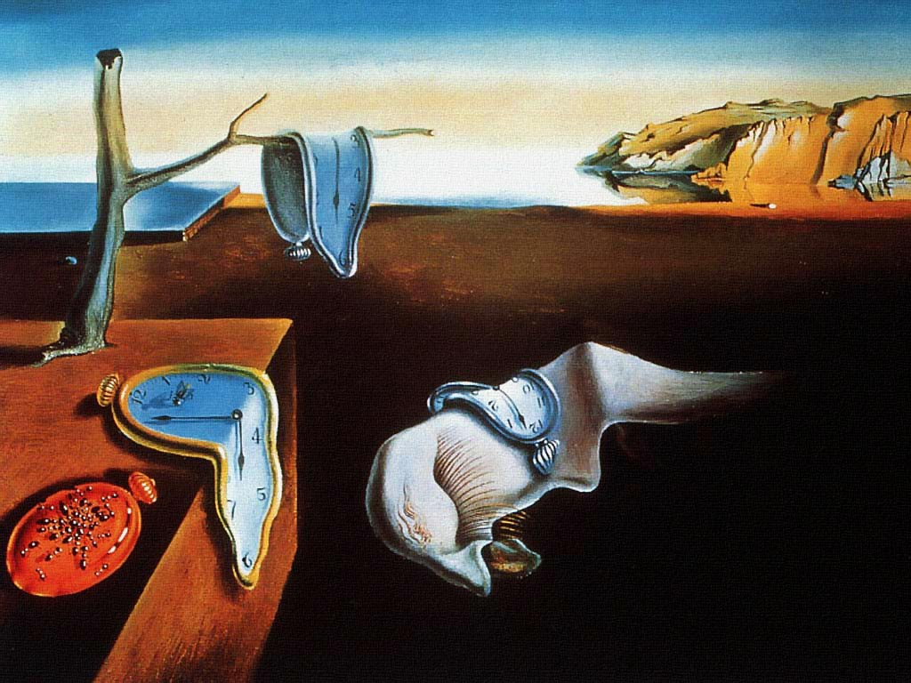

Top Left: A picture of Salvador Dali
Top Right: “The Temptation of St. Anthony”
Center: “The Persistence of Memory”
Regionalism- artists that depicted scenes unique to their sections of the country
- Became popular in the 1930’s
- Edward Hopper is an example of a regional artist
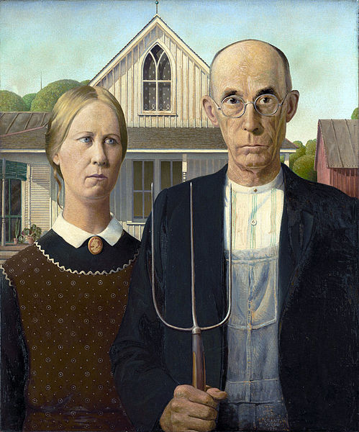
Grant Wood- @ 1892-1942
- Another Regional Artist
- Most known for his painting American Gothic

Georgia O’Keefe- @ 1887-1986
- Regional artist
- Became well-known for painting images of flowers in a more abstract way
- Also incorporated desert scenes from her home in New Mexico called “Ghost Ranch”

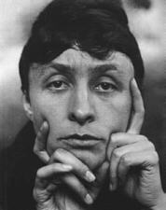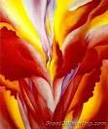

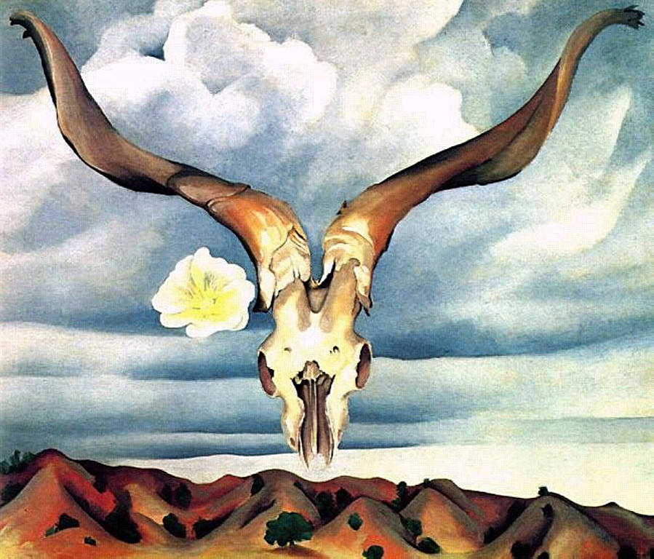
Abstract Expressionism- artists applied paint to their canvases with large, loose gestures and often times dripped or threw paint.
- Wanted to express their emotions and feelings rather than create a realistic work of art
- Emphasized the action of applying paint to the surface
- Term was coined by Harold Rosenburg- an art critic that categorized modern artists artwork.
- Most popular abstract expressionist artist was Jackson Pollock

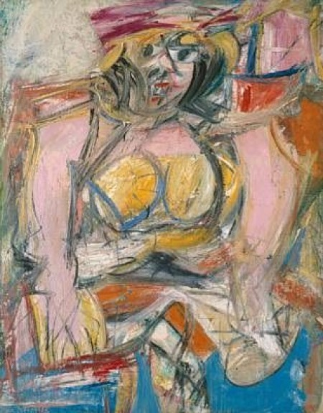
Willem de Kooning- @ 1904-1997
- Abstract expressionist painter
- Married to Elaine de Kooning
Image on left: “Woman” created in 1950

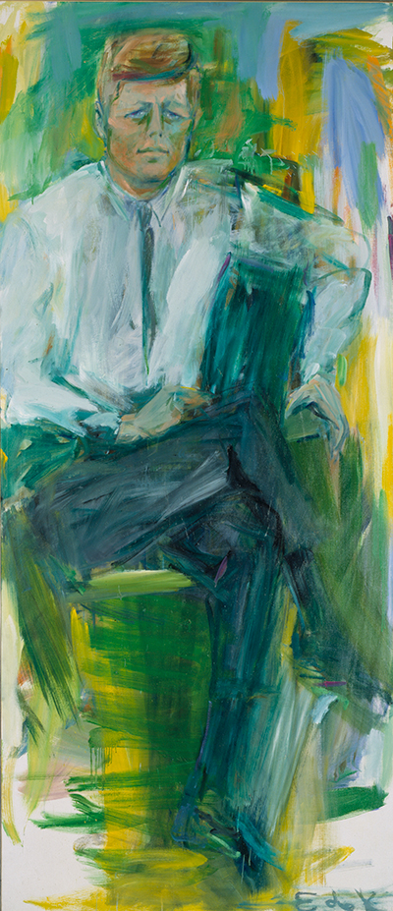
Elaine de Kooning-
- Married to Willem de Kooning
- Abstract expressionist painter
- Both an artist and an art critic

Image on Left: “John F. Kennedy” Created @ 1963

Jackson Pollock- @ 1912-1956
- Most famous/ influential abstract expressionist painter
- Worked for the WPA (Works Progress Association) from 1935-1943
- Most famous paintings were created between 1947-1950
  - Stopped using the drip style and began to reintroduce figurative element into his artwork.
- Harold Rosenburg coined his type of creating art was “Action painting”
  - Action painting- the process by which you create abstract expressionism
  - Artists would stand on top of their canvas and paint like they are a part of their artwork.
  - Pollock would stand on his painting and applied the paint in a dance-like manner; he would splash paint and stand on all 4 sides of the canvas; created a unique event in each painting.
- Pollock was an alcoholic and struggled with his addiction his whole life and ultimately killed him when he was in a single car accident in 1956

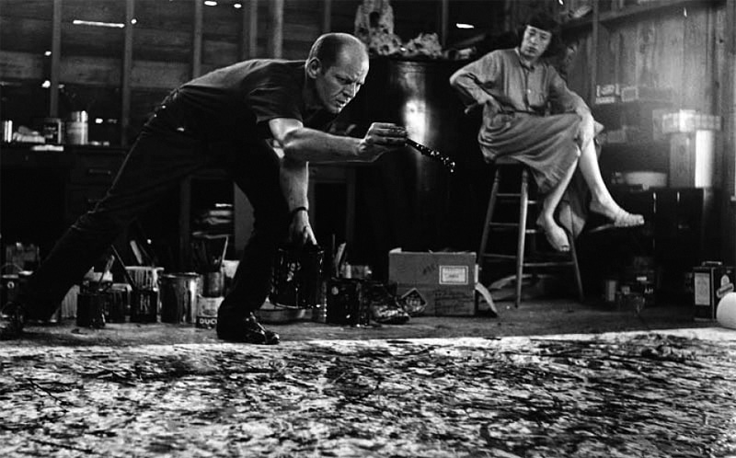

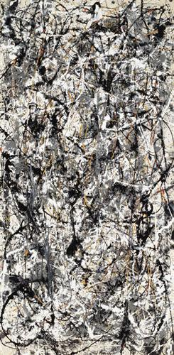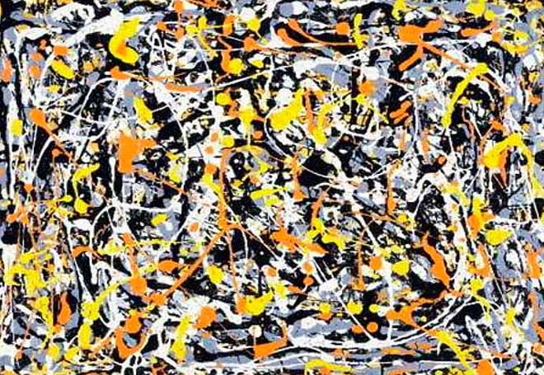
Pop Art- used images from popular culture in the 1960’s
- Ex. Campbell soup cans, comic book images etc.
Andy Warhol- @ 1928-1987
- One of the most popular of the pop artists
- Created the famous images of the Campbell Soup Cans
- Also created prints by using a silk screen printing press

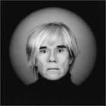

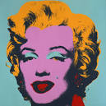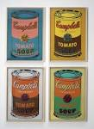

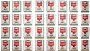

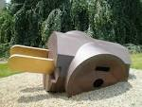
Claes Oldenburg- @ 1929- (he’s still alive)
- Sculptor that created the “Three Way Plug”

Op Art- nonobjective style that developed in the United States after 1960; there is no reference to reality, meaning the artwork looks very formal
- Think of optical illusions
Bridget Riley- @ 1931- (She is still alive today)
- One of the leading Op Art artists
- Concerned with the idea of the participation of the audience was needed in order to appreciate the art.
  - Think of your experience when you look at optical illusions and how if she didn’t have an effect on the audience how the meaning and purpose of art would change…

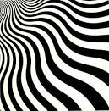

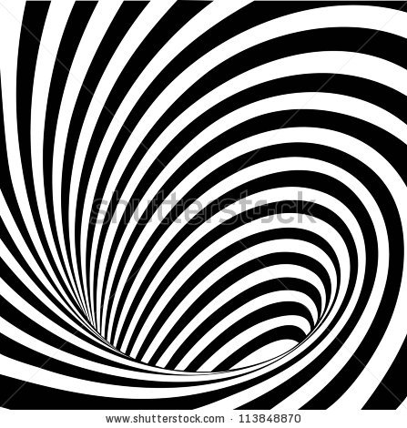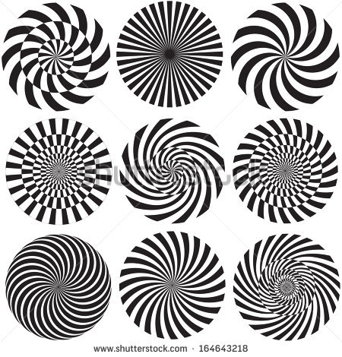

Hard Edge Painters- placed great importance on the crisp edges of their work
- Used simple geometric shapes with bright colors and hard edges

Frank Stella- @ 1936- (He is still alive today)
- One of the leading hard edge painters
- Created HUGE geometric paintings that had hard edges and the shapes were separated by the white of the unpainted canvas.

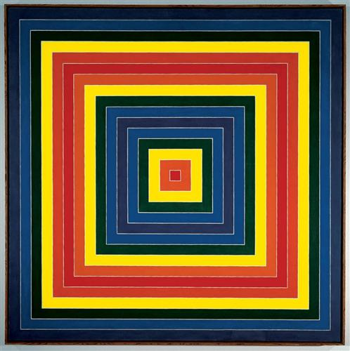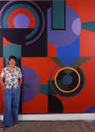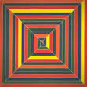
Photo-Realism- created around the 1970’s where artists were concerned with creating works of art that looked as real as a photograph
- This art movement was successful because most of the works of art were non-objective during this time and took little to no artistic training or skill
- This movement was successful because it took skill and training and was appreciated by people who were sick of seeing popular imagery and works of art they felt themselves could make
Alfred Leslie-
- Turned away from abstract expressionism and looked to art from the past for inspiration
- Used strong light to illuminate the figure in the portrait of a young girl

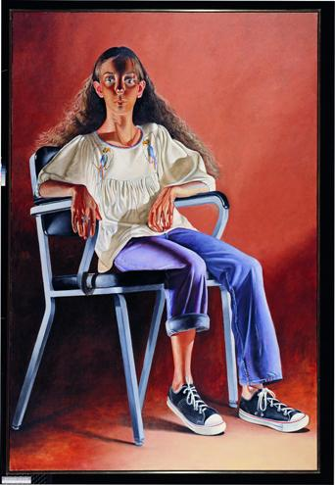
Postmodernism- This is the art movement we are experiencing right now.
- Characterized by artist choosing the type of artworks they want to create and are not controlled by a particular art movement to dictate what style, manner or subject matter they created.

The following is an example of what artists are creating today (2000’s)

Hyperrealism- works of art that stemmed from photo-realism that depict a high resolution camera
- Works of art are generally MASSIVE in order to create the most realistic imagery
- Movement started in the early 2000’s and is still continuing today

Can you believe the following images are made with pencil?

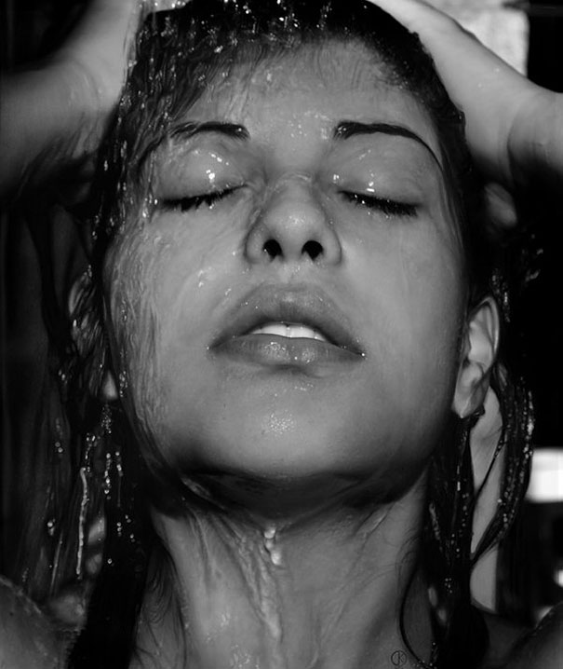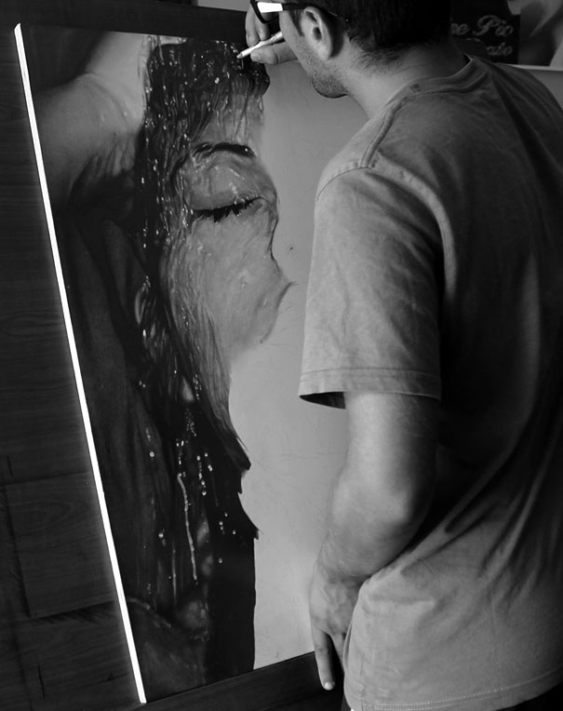

The following image is a Hyperrealism sculpture

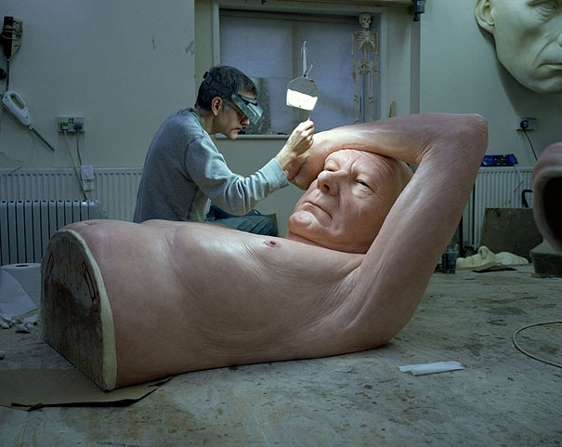
Hyperrealist Artist’s paint everyday images we see in society and can relate to

