Lesson # 5
Guided Reading
Ancient Rome
Etruscans- civilized and powerful people
- Little is known because their language has not completely been understood
- Originally came from Asia Minor
- Came as early as 1000 BCE
- Culture, writing, hydraulic engineering
- Formed powerful city-states
- Taken over by the Roman Revolt @ 509 BCE
Etruscan Artworks- mainly paintings, gold work, jewelry and clay pots
- Etruscan Tomb Painting-
  - @ 480 BCE
- Etruscan Sarcophagus of Bride and Bridegroom-
  - @ 6th Century
- Terracotta- type of clay used in most Etruscan Pottery
The Republic- @ 509-27 BCE
- Roman control stretched from Britain to Mesopotamia
- Decline: caused by the move of the capitol
  - Moved from Rome to Greece called Constantinople @ 330 ACE (After Common Era)
  - @ 410 ACE Alaric, King of the Visigoths invaded Rome
  - At the same time, barbarians were attacking from the north
  - By the 5th Century, the Roman Empire ended
Influences on Roman Art- Roman and Greek art are VERY similar
- Greek Artists were commissioned, paid money, to create works of art in Rome
- Major differences from Roman and Greek Art is seen in Architecture

Sculpture- favored realism, statues and sculptures that looked life-like
- Lost Wax Relief- sculpture made out of wax, then made into a mold
  - Wax was heated up and melted out of mold, they then could pour bronze or any metal into the mold and get the same sculpture they started with
- Characteristics of Sculpture-
  - Exaggerated or emphasized facial expressions; they look like a certain emotion
  - Looked like the person they were trying to recreate

Murals- pictures or images that were painted directly on the walls
- Most all walls were covered with murals
- Usually were of landscapes or imaginary windows
- Pompeii- Not a lot is known about Pompeii because the city was destroyed by a volcano, Mount Vesuvius, that left the city buried in ash and pumice in 79 ACE
  - See examples of Pompeii on link

Architecture- Romans built roads, harbors, aqueducts, sewers, temples and other buildings
- Most all construction was made out of stone or concrete
  - The Romans did not invent concrete! They just use it in their architecture
- Round Arch- Replaced the post and lintel system
  - Made of stone or concrete and held together by a keystone, the center stone at the top middle
  - 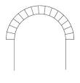
- Barrel Vault- used to cover a large straight area
  - Imagine if you stacked round arches back to back until it made a tunnel
  - 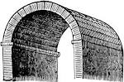
- Groin Vault- When two barrel vaults meet or make a “t”
  - These are used when there is a corner in a building
  - 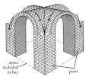

- Niches- a “cut out” or recess in a wall
  - Usually held sculptures or murals
  - 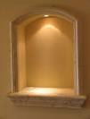
- Basilicas- large rectangular halls
  - Used for courts of law or meeting areas
  - Usually had columns lining each side
  - 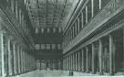
- Nave- center aisle, think of a church where you sit.
  - Similar to basilica
- Apse- semi-circular area at the end of the nave
  - 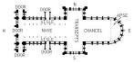
  - Imagine you are looking down on a building. The APSE is labeled and on the far right side
- Aqueducts- a system used to carry water into towns and cities from country streams and rivers using gravitational flow
  - 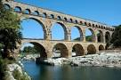

Temples- Major Temples include Pantheon and Parthenon
Pantheon- Temple that was built by Romans for ALL gods
- @ 118 BCE -25 ACE
- Shaped like a large cylinder with a massive dome on top
- No windows in entire building
  - Light enters through holes in the dome that illuminate or light the entire building
  - 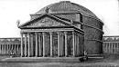

  - 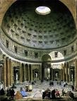 See the large hole letting light in?

Parthenon- Temple that was built by Greeks in honor of ONE god Athena
- @ 447-438 BCE
- 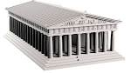
- 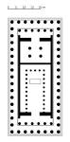All the Black dots are columns
- A sculpture of Athena is located in the center of building

